**Chapter No 1**

**Introduction**

**1.1 Project Background:-**

Online Tours & Travels management system: This is an online project developed using PHP and MySQLi. The purpose of this project is to provide the complete information about the vehicles available for a tour. There are 2 different types of users. First the customer visits the site and enters the place from where to where he wishes to travel. User can sign up after that they can able login into the site, they can search for the different trips, flight details, bus details etc., After searching they can able to book the tickets. Online Tour and Traveling Booking is a system that gives you facility of booking any type of Tours and Travels. This system is made so that Customer will not have to come to us to Book his\her Tours. The project ‘Tours and Travels Management System’ is developed to replace the currently existing system, which helps in keeping records of the customer ,details of destination as well as payment received. In the present era where “time” proves to be the most important asset for an individual by replacing the current register system to fully computerize, it not only saves the precious asset that is time, but also accuracy, reliability and uniformity can be maintained. This project is useful for the manager of the company as it helps them to search the data faster than existing system, to get customer record easily and report of the customer, payment are generated as per requirement.

**1.2 Description of project:-**

Tours & Travels Management System Transport solution to the different companies situated locally in the many districts and it organizes tours to various part of the country. Earlier all the processes were done manually. The manual process is done by maintaining the details of the tours, employees and their customers. Details of the employees of the system is maintained in the office. It includes details of both the moving staff (driver) and the non-moving staff (clerk).Details related to the salary of the employees is maintained. Salary of the clerk and the manager is calculated on the basis of monthly attendance and the salary of the driver is calculated on the basis of the trips made by the drivers. Salary of the employees are deducted on the basis of absence made by the employee. Details of no. of days the employee remained absent in a month is also maintained. Details of different types of tours are maintained. As the customer ask for the details of a particular tour, the clerk gives the details of the related place where he/she wants to go and no. of seats available of that particular tour, fair of the tour, details of discount on a particular tour package if any. Clerk also guides the customer by giving the details of the forthcoming tours with the probable date and time. Details of types of bus like 3x2 or 2x2 for the tours. Details of total no. of days of the tour and the places to visit during the tour is also maintained. Details of the pick-up facilities and the drop facilities are also maintained if any. Details of the hotels in which the accommodation of the customer will be done during the tours. Details like availability of meals, station-pickup and drop facility and contact no. of the hotels are also provided to the customers on special request.

**1.3 Objective of the Project:-**

Faster processing time and more accurate data for travel requests and reimbursements. Ability for travelers to track authorization and reimbursement request status through the system rather than via phone calls or campus mail. Major technological upgrades to the current travel system. Use of IU’s standardized, virtual J2EE environments. Many new features and enhancements

**1.4 Scope of Project:-**

Gone are the days when one used to call multiple travel agents to know about the holiday packages and plan a tour. With the advent of Word Wide Web, it is observed widely that there is a rapid rise in the number of online travel portals which provides last minute holiday packages and from the comfort of home, one can surf the internet and access a plethora of information on various tour packages, look up for holiday destinations, getting hotel information, booking travel tickets online and everything made easy at a click of a button. In Pakistan, tourism industry is experiencing an exponential growth with rise in foreign exchange earnings contributing to around 5.9% Gross Domestic Product (GDP). As per the World Travel and Tourism Council, the tourism industry is likely to generate USD 121.4 billion economic activity by 2015 creating hope for optimistic future. With the evolution of the internet and increase in internet literacy rate, now the people have a choice to move from counter booking to online booking and they are ready to pay for the convenience and better service which the online travel portals offers them, and all these key factors makes sure that, in the coming years the online travel business sector will immensely boom.

**Chapter No 2**

**Literature Review**

**Fly Dubai:-**

Government of DubaiManagement and ownership. The company was formed on 19 March 2008 as a venture by the Government of Dubai. The Government of Dubai also owns Emirates Airlines; however, the common ownership is the only connection between the two airlines. Fly Dubai is the most affordable airline which includes both comfort and over the edge technology, Fly Dubai offers remarkable service in both the air and the ground. Fly Dubai is not an airline which will fry your budget, you should look forward to travel with Fly Dubai if you want the best flight experience in low price. Fly Dubai commenced its operations in 2008, and since then has become a popular choice for travelers on a budget. Fly Dubai connects you to several destinations across Middle East, Europe, Central Asia and More. Fly Dubai's young fleet consists of around 70+ New Boeing 737-800 Air Crafts, Fly Dubai airline carrier also have undergone requests for 100 more Boeing 737-800 to meet the demands of expanding airline network and to accomplish great things in future. Their no frills approach to flying cuts costs and offers customers low prices on tickets to roughly 95 destinations all year round. This year, the airline slashed its prices by over 35% as a new year campaign, encouraging people to plan their travel at the beginning of the year Fly Dubai also introduced ‘Business Class’ in 2013 and is recognized for creatively using the Emirati cartoon ‘Freej’ in their inflight safety video. Fly Dubai online booking is available with tajawal. Features of web, Make a booking table, manage booking, check in online, Timetable, Flights status. And the advantages of that company is cheapest price, Book online, Easy to use, Reliable.

**Air Blue:-**

Air Blue Limited is a private Pakistani low-cost airline with its head office on the 12th floor of the Islamabad Stock Exchange Towers in Islamabad, Pakistan. Air Blue operates scheduled domestic and international flights to Oman, Saudi Arabia and the United Arab Emirates.[Islamabad](https://www.google.com/search?rlz=1C1CHZL_enPK836PK836&q=Islamabad&stick=H4sIAAAAAAAAAOPgE-LUz9U3MM3OtjBV4gAxUzJSTLW0spOt9POL0hPzMqsSSzLz81A4VhmpiSmFpYlFJalFxYtYOT2LcxJzE5MSUwDGcFl5TwAAAA&sa=X&ved=2ahUKEwiozPmR8KzhAhVoURUIHcvdCvIQmxMoATAeegQICxAH)[18 June 2004](https://www.google.com/search?rlz=1C1CHZL_enPK836PK836&q=18+June+2004&stick=H4sIAAAAAAAAAONgVhLQL9E3Sso1LjdLMTPPMk5JWsTKY2ih4FWal6pgZGBgAgAVVkTWIwAAAA&sa=X&ved=2ahUKEwiozPmR8KzhAhVoURUIHcvdCvIQmxMoATAfegQICxAL) duration14 [Founder](https://www.google.com/search?rlz=1C1CHZL_enPK836PK836&q=airblue+founder&stick=H4sIAAAAAAAAAOPgE-LUz9U3MM3OtjDVUs9OttJPKi3OzEstLoYz4vMLUosSSzLz86zS8kvzUlKLFrHyJ2YWJeWUpipARQCLyn9kSAAAAA&sa=X&ved=2ahUKEwiozPmR8KzhAhVoURUIHcvdCvIQ6BMoADAhegQICxAR)[Shahid Khaqan Abbasi](https://www.google.com/search?rlz=1C1CHZL_enPK836PK836&q=Shahid+Khaqan+Abbasi&stick=H4sIAAAAAAAAAOPgE-LUz9U3MM3OtjBVAjOTy3Kyy7XUs5Ot9JNKizPzUouL4Yz4_ILUosSSzPw8q7T80ryU1KJFrCLBGYkZmSkK3hmJhYl5Co5JSYnFmQBfQrW2WAAAAA&sa=X&ved=2ahUKEwiozPmR8KzhAhVoURUIHcvdCvIQmxMoATAhegQICxAS), founded 2003, [Karachi](https://www.google.com/search?rlz=1C1CHZL_enPK836PK836&q=Karachi&stick=H4sIAAAAAAAAAOPgE-LUz9U3MM3OtjBV4gAxTZKz8rRUs5Ot9POL0hPzMqsSSzLz81A4Vmn5pXkpqSmLWNm9E4sSkzMyAdYR0IhIAAAA&sa=X&ved=2ahUKEwiozPmR8KzhAhVoURUIHcvdCvIQmxMoATAiegQICxAW) [Hub](https://www.google.com/search?rlz=1C1CHZL_enPK836PK836&q=airblue+hub&stick=H4sIAAAAAAAAAOPgE-LUz9U3MM3OtjDVUswot9JPzs_JSU0uyczP088vSk_My6xKBHGKrTJKk4oXsXInZhYl5ZSmKgC5AIHt13o-AAAA&sa=X&ved=2ahUKEwiozPmR8KzhAhVoURUIHcvdCvIQ6BMoADAjegQICxAZ)[Jinnah International Airport](https://www.google.com/search?rlz=1C1CHZL_enPK836PK836&q=Jinnah+International+Airport&stick=H4sIAAAAAAAAAOPgE-LUz9U3MM3OtjBVAjOTCwpT4rUUM8qt9JPzc3JSk0sy8_P084vSE_MyqxJBnGKrjNKk4kWsMl6ZeXmJGQqeeSWpRXlgqcQcBcfMooL8ohIAKh-br1oAAAA&sa=X&ved=2ahUKEwiozPmR8KzhAhVoURUIHcvdCvIQmxMoATAjegQICxAa) (Karachi)The airline was established in 2003 and started operations on 18 June 2004 with three leased [Airbus A320-200](https://en.wikipedia.org/wiki/Airbus_A320_family) aircraft serving Karachi–Lahore and Karachi–Islamabad with three daily flights in each direction. The airline was inaugurated in 2004 by Prime Minister [Zafarullah Khan Jamali](https://en.wikipedia.org/wiki/Zafarullah_Khan_Jamali). During the first year the airline became very popular, which allowed the airline to compete directly with the flag carrier [Pakistan International Airlines](https://en.wikipedia.org/wiki/Pakistan_International_Airlines) and the two other private carriers, flying more than 400,000 passengers in the first year with a [load factor](https://en.wikipedia.org/wiki/Passenger_load_factor) of over 90%.This allowed the airline to expand into more cities in Pakistan including [Peshawar](https://en.wikipedia.org/wiki/Peshawar), [Quetta](https://en.wikipedia.org/wiki/Quetta) and [Nawabshah](https://en.wikipedia.org/wiki/Nawabshah). On 14 August 2005 Air Blue launched its first international flight from Karachi to [Dubai](https://en.wikipedia.org/wiki/Dubai). On June 4, 2007, Air Blue launched its inaugural flight to [Manchester](https://en.wikipedia.org/wiki/Manchester,_England) using the [Airbus A321](https://en.wikipedia.org/wiki/Airbus_A321). Air Blue changed its IATA code from ED to PA in June 2012, the new code originally belonged to the defunct and once iconic carrier [Pan American World Airways](https://en.wikipedia.org/wiki/Pan_American_World_Airways). In 2011 the airline launched service to Istanbul’s [Sabiha Gokcen Airport](https://en.wikipedia.org/wiki/Sabiha_Gokcen_Airport) - a route which was ultimately terminated. In June 2012, Air Blue finalized an agreement to acquire one Airbus A320 and two leased [A340-300s](https://en.wikipedia.org/wiki/Airbus_A340) for existing and new international routes. It was also looking at various types of turboprop aircraft for new domestic routes but this plan was eventually dropped. The A340s joined the fleet in October 2012, enabling the airline to strengthen its Manchester route with nonstop flights as well as launch a second UK destination [Birmingham](https://en.wikipedia.org/wiki/Birmingham) in September 2013, and connect both stations with Lahore. The A340s later also flew to the Middle East. Technical issues related to the aircraft eventually led to them being phased out by January 2014; they had been leased for a five-year term. UK operations also ended with Birmingham being dropped after just three months' service and Manchester ending in January 2014.Featuresof web is Cabin, e-Ticketing, Frequent flyer program, Lounges, Cargo operations, Search Flights. Advantages is User friendly. Online booking. Schedules.

**Tripit:-**

[Founded](https://www.google.com/search?rlz=1C1CHZL_enPK836PK836&q=tripit+founded&stick=H4sIAAAAAAAAAOPgE-LSz9U3MKrIMU7O01LNTrbSzy9KT8zLrEosyczPQ-FYpeWX5qWkpixi5SspyizILFGACgAAtvNxAEYAAAA&sa=X&ved=2ahUKEwinyOPn86zhAhUkSRUIHTu1DesQ6BMoADAiegQICxAD) in October 2006, [San Francisco, California, United States](https://www.google.com/search?rlz=1C1CHZL_enPK836PK836&q=San+Francisco&stick=H4sIAAAAAAAAAOPgE-LSz9U3MKrIMU7OU-IAsVPMcgq0VLOTrfTzi9IT8zKrEksy8_NQOFZp-aV5Kakpi1h5gxPzFNyKEvOSM4uT8wGlTbTbTwAAAA&sa=X&ved=2ahUKEwinyOPn86zhAhUkSRUIHTu1DesQmxMoATAiegQICxAE). [Headquarters](https://www.google.com/search?rlz=1C1CHZL_enPK836PK836&q=tripit+headquarters&stick=H4sIAAAAAAAAAOPgE-LSz9U3MKrIMU7O09LKTrbSzy9KT8zLrEosyczPQ-FYZaQmphSWJhaVpBYVL2IVLinKLMgsUUAWBQC0jO1KUAAAAA&sa=X&ved=2ahUKEwinyOPn86zhAhUkSRUIHTu1DesQ6BMoADAjegQICxAH) in [San Francisco, California, United States](https://www.google.com/search?rlz=1C1CHZL_enPK836PK836&q=San+Francisco&stick=H4sIAAAAAAAAAOPgE-LSz9U3MKrIMU7OU-IAsVPMcgq0tLKTrfTzi9IT8zKrEksy8_NQOFYZqYkphaWJRSWpRcWLWHmDE_MU3IoS85Izi5PzAWq6MadUAAAA&sa=X&ved=2ahUKEwinyOPn86zhAhUkSRUIHTu1DesQmxMoATAjegQICxAI) [Parent organization](https://www.google.com/search?rlz=1C1CHZL_enPK836PK836&q=tripit+parent+organization&stick=H4sIAAAAAAAAAOPgE-LSz9U3MKrIMU7O0zLIKLfST87PyUlNLsnMz9PPL0pPzMusSgRxiq0KEotS80oUkAUXsUqVFGUWZJYoYJEEAFt063BdAAAA&sa=X&ved=2ahUKEwinyOPn86zhAhUkSRUIHTu1DesQ6BMoADAkegQICxAL) is [SAP Concur](https://www.google.com/search?rlz=1C1CHZL_enPK836PK836&q=Concur&stick=H4sIAAAAAAAAAOPgE-LSz9U3MKrIMU7OU4Kwi0rKCsq1DDLKrfST83NyUpNLMvPz9POL0hPzMqsSQZxiq4LEotS8EgVkwUWsbM75ecmlRQAmGFM9VQAAAA&sa=X&ved=2ahUKEwinyOPn86zhAhUkSRUIHTu1DesQmxMoATAkegQICxAM). [Founders](https://www.google.com/search?rlz=1C1CHZL_enPK836PK836&q=tripit+founders&stick=H4sIAAAAAAAAAOPgE-LSz9U3MKrIMU7O01LPTrbSTyotzsxLLS6GM-LzC1KLEksy8_Os0vJL81JSixax8pcUZRZklihABYoBH7aIRkkAAAA&sa=X&ved=2ahUKEwinyOPn86zhAhUkSRUIHTu1DesQ6BMoADAlegQICxAP) are [Scott Hintz](https://www.google.com/search?rlz=1C1CHZL_enPK836PK836&q=Scott+Hintz&stick=H4sIAAAAAAAAAOPgE-LSz9U3MKrIMU7OUwKzjdMzcosLtNSzk630k0qLM_NSi4vhjPj8gtSixJLM_DyrtPzSvJTUokWs3MHJ-SUlCh6ZeSVVALdhS8dRAAAA&sa=X&ved=2ahUKEwinyOPn86zhAhUkSRUIHTu1DesQmxMoATAlegQICxAQ), [Gregg Brockway](https://www.google.com/search?rlz=1C1CHZL_enPK836PK836&q=Gregg+Brockway&stick=H4sIAAAAAAAAAOPgE-LSz9U3MKrIMU7OUwKzjdMzcsvMtNSzk630k0qLM_NSi4vhjPj8gtSixJLM_DyrtPzSvJTUokWsfO5FqenpCk5F-cnZ5YmVAMXD2OVUAAAA&sa=X&ved=2ahUKEwinyOPn86zhAhUkSRUIHTu1DesQmxMoAjAlegQICxAR), [Andy Denmark](https://www.google.com/search?rlz=1C1CHZL_enPK836PK836&q=Andy+Denmark&stick=H4sIAAAAAAAAAOPgE-LSz9U3MKrIMU7OUwKzjdMzcovMtdSzk630k0qLM_NSi4vhjPj8gtSixJLM_DyrtPzSvJTUokWsPI55KZUKLql5uYlF2QAqs1_4UgAAAA&sa=X&ved=2ahUKEwinyOPn86zhAhUkSRUIHTu1DesQmxMoAzAlegQICxAS). SAP Concur (formerly, Concur Technologies) is an American [SaaS](https://en.wikipedia.org/wiki/Software_as_a_service) company, providing travel and expense management services to businesses. It is headquartered in [Bellevue, Washington](https://en.wikipedia.org/wiki/Bellevue,_Washington). [SAP SE](https://en.wikipedia.org/wiki/SAP_SE) agreed to acquire Concur Technologies in September 2014 for $8.3 billion. The deal was completed in December 2014.SAP Concur was founded by Steve Singh, is now headed by Mike Eberhard and part of [SAP's Business Network Group](https://blogs.sap.com/2015/09/16/what-is-sap-s-business-networks-group-find-out-opensap/) beside [SAP Ariba](https://en.wikipedia.org/wiki/SAP_Ariba) and [SAP Field glass](https://www.fieldglass.com/). The company is headquartered in Bellevue, Washington, with additional offices in [Vienna (Virginia)](https://en.wikipedia.org/wiki/Vienna,_Virginia), [Allen (Texas)](https://en.wikipedia.org/wiki/Allen,_Texas), [Eden Prairie (Minnesota)](https://en.wikipedia.org/wiki/Eden_Prairie,_Minnesota), [St. Louis Park (Minnesota)](https://en.wikipedia.org/wiki/St._Louis_Park,_Minnesota), [Europe](https://en.wikipedia.org/wiki/Europe), [Asia](https://en.wikipedia.org/wiki/Asia), and Australia. [SAP](https://en.wikipedia.org/wiki/SAP_SE) entered into an agreement to acquire Concur Technologiesfor US$8.3 billion. The acquisition was completed on December 4, 2014.In 2016, Concur acquired Hipmunk, a startup company offering a flight and hotel search website. During an August 2018 briefing, the [Department of Defense](https://en.wikipedia.org/wiki/Department_of_Defense) announced that it was partnering with SAP Concur to update Defense Travel System used for active duty, reserve, and civilian personnel of the DOD. Features is Automate expenses from receipt to reimbursement. Proactively manage spend with AP automation. Capture and manage invisible bookings. Leverage our industry-leading innovations and spend more time growing your business. Advantages is automation expenses system. Online booking. Easy to use.

**Viator:-**

[Viator](https://en.wikipedia.org/wiki/Viator) is a municipality in Spain. Viator may also refer to [Saint Viator (disambiguation)](https://en.wikipedia.org/wiki/Saint_Viator_(disambiguation)), multiple saints. [Viator picis](https://en.wikipedia.org/wiki/Viator_picis), an extinct lapwing species and genus. In the insurance industry, a viator is an owner of a life insurance policy, who sells (viaticates) a life insurance policy through a [viatical settlement](https://en.wikipedia.org/wiki/Viatical_settlement). Viator, a travel brand acquired by [Trip Advisor](https://en.wikipedia.org/wiki/TripAdvisor) in 2014.Features of viator are Tour suggestion. Destination suggestion. Top Attractions. Advantages is online booking. Login option.

**Airbnb:-**

A‌i‌r‌b‌n‌b‌,‌ ‌I‌n‌c‌.‌ is a privately held global company headquartered in [San Francisco](https://en.wikipedia.org/wiki/San_Francisco) that operates an [online marketplace](https://en.wikipedia.org/wiki/Online_marketplace) and [hospitality service](https://en.wikipedia.org/wiki/Hospitality_service) which is accessible via its [websites](https://en.wikipedia.org/wiki/Website) and [mobile apps](https://en.wikipedia.org/wiki/Mobile_app). Members can use the service to arrange or offer [lodging](https://en.wikipedia.org/wiki/Lodging), primarily [homestays](https://en.wikipedia.org/wiki/Homestay), or [tourism](https://en.wikipedia.org/wiki/Tourism) experiences. The company does not own any of the [real estate](https://en.wikipedia.org/wiki/Real_estate) listings, nor does it host events; as a [broker](https://en.wikipedia.org/wiki/Broker), it receives [commissions](https://en.wikipedia.org/wiki/Commission_(remuneration)) from every booking .Features are Guests can search for lodging using filters such as lodging type, dates, location, and price. Before booking, users must provide personal and payment information. Some hosts also require a scan of a government-issued identification before accepting a reservation. The company also provides [travel guides](https://en.wikipedia.org/wiki/Travel_guide), entitled "Neighborhoods", which provide details about staying in specific neighborhoods in various major cities. Hosts provide prices and other details for their rental or event listings. Pricing is determined by the host, with recommendations from Airbnb. Hosts may be required to report income and pay [income taxes](https://en.wikipedia.org/wiki/Income_tax) on income received via Airbnb. In the US, homeowners who refinance their mortgages with some agencies are able to count income they earn from Airbnb rentals on their refinance loan application. Some cities have restrictions on subletting for a short period of time. Airbnb has published a list of regulations and requirements for cities in the United States. In some cities, collection of a [transient occupancy tax](https://en.wikipedia.org/wiki/Transient_occupancy_tax) by Airbnb is required. In many cities, hosts must register with the government and obtain a permit or license Landlords or community associations may have restrictions on short-term sublets. Founder Joe Gebbia has said that Airbnb is specifically "designed for trust" and provides a variety of safety mechanisms, including US$1,000,000 of secondary insurance, which covers [property damage](https://en.wikipedia.org/wiki/Property_damage) by guests due to [vandalism](https://en.wikipedia.org/wiki/Vandalism) and/or [theft](https://en.wikipedia.org/wiki/Theft), and connection to multiple [social media](https://en.wikipedia.org/wiki/Social_media) channels. Advantages is fair housing implications and discrimination. Privacy and terms of use. Pricing transparency. Housing affordability. Use of double Irish arrangement

**Home Away:-**

### February 2005, Brian Sharples, Carl Shepherd Key people of websites John Kim ([President](https://en.wikipedia.org/wiki/President_(corporate_title))),Trent York ([CFO](https://en.wikipedia.org/wiki/Chief_financial_officer)),Jeff Hurst ([CCO](https://en.wikipedia.org/wiki/Chief_commercial_officer)),Tina Weyand ([CPO](https://en.wikipedia.org/wiki/Chief_product_officer)),John J. Ostlund ([CTO](https://en.wikipedia.org/wiki/Chief_technology_officer)), Steve Davis ([CIO](https://en.wikipedia.org/wiki/Chief_information_officer)), Jeff Mosler ([CSO](https://en.wikipedia.org/wiki/Chief_services_officer)). Home away is a [vacation rental](https://en.wikipedia.org/wiki/Vacation_rental) marketplace with more than 2,000,000 vacation rentals in 190 countries listed on its website. It operates through 50 websites in 23 languages through which it offers rentals of cabins, condos, castles, villas, barns, and farmhouses. Founded in February 2005 and headquartered in [Austin, Texas](https://en.wikipedia.org/wiki/Austin,_Texas), the company became a publicly traded company in 2011. [Expedia](https://en.wikipedia.org/wiki/Expedia_Group) acquired Home away on December 15, 2015.HomeAway was founded in 2004 as CEH Holdings. The company acquired several websites and consolidated them into a single vacation marketplace, launching HomeAway.com in June 2006. Home away moved into its new global headquarters in Austin, Texas, on October 2, 2009. It was the first mixed-use project and the second company in Austin to achieve [LEED](https://en.wikipedia.org/wiki/Leadership_in_Energy_and_Environmental_Design) Gold certification for Commercial Interior Design. In 2009, [Us Weekly](https://en.wikipedia.org/wiki/Us_Weekly) magazine announced that Home away would reunite actors [Chevy Chase](https://en.wikipedia.org/wiki/Chevy_Chase) and Beverly D’Angelo in a new short film and advertising campaign based on the movie [National Lampoon’s Vacation](https://en.wikipedia.org/wiki/National_Lampoon%E2%80%99s_Vacation). The Home away ad represented the company’s first national advertising campaign. It debuted during the CBS television network broadcast of [Super Bowl XLIV](https://en.wikipedia.org/wiki/Super_Bowl_XLIV) on February 7, 2010 .Home away raised a total of $405 million in venture-capital which was funded by [venture capital](https://en.wikipedia.org/wiki/Venture_capital) firms [Austin Ventures](https://en.wikipedia.org/wiki/Austin_Ventures), [Institutional Venture Partners](https://en.wikipedia.org/wiki/Institutional_Venture_Partners),  [Redpoint Ventures](https://en.wikipedia.org/wiki/Redpoint_Ventures), Technology Crossover Ventures, and Trident Capital. Home away IPO stock closed at $40.21 on Nasdaq, up 49% from its IPO price of $27.Feature are Business Model. Finance. Legal status.

**Shaheen Airline:-**

Shaheen Air ([Urdu](https://en.wikipedia.org/wiki/Urdu_language): شاہین ایئر‎) was a [private](https://en.wikipedia.org/wiki/Private_sector) Pakistani airline with its head office at [Jinnah International Airport](https://en.wikipedia.org/wiki/Jinnah_International_Airport) in [Karachi](https://en.wikipedia.org/wiki/Karachi) and is owned by the Khalid Shehbai family and originally established by the [Shaheen Foundation](https://en.wikipedia.org/wiki/Shaheen_Foundation). Shaheen Air was providing passenger, cargo and charter services, to major cities in Pakistan and the [Middle East](https://en.wikipedia.org/wiki/Middle_East). It suspended all operations in October 2018.Shaheen Air Cargo is a division of Shaheen Air International that was established in 1993, soon after the inception of the airline. Shaheen Air provides special services for sending small consignments that are time-sensitive in nature. On 22 May 2004, the [Civil Aviation Authority of Pakistan](https://en.wikipedia.org/wiki/Civil_Aviation_Authority_of_Pakistan) (CAA) grounded Shaheen Air as the airline owed it millions of rupees. Three days later the airline was cleared by the CAA to resume its domestic and international operations. The clearance letter was issued by CAA following receipt of a payment from Shaheen Air International towards the outstanding dues and funds. The same year, Shaheen Air International (SAI) became Shaheen Air and the airline introduced a new livery and corporate website. Shaheen Air started its own maintenance repair organization (MRO) by the name of *Shaheen Engineering and Aircraft Maintenance Services* (SEAMS) which aims to provide maintenance services to Shaheen Air as well as other regional and international airlines. In its international operations, Shaheen Air also operated between Pakistan and numerous destinations in the [Middle East](https://en.wikipedia.org/wiki/Middle_East). Shaheen Air once started flight operations to Riyadh with three different routes from Pakistan. Shaheen Air was Pakistan's second largest airline next to the flag carrier, [Pakistan International Airlines](https://en.wikipedia.org/wiki/Pakistan_International_Airlines) but due to the recent downfall in the year 2018, the airline lost its business and struggled for survival. The airline was declared as the defaulter by PCAA and FBR. In October 2018, SAI flight operation completely suspended by local regularity body PCAA and airline declared as financially defaulter. Currently, airline [Air operator's certificate](https://en.wikipedia.org/wiki/Air_operator%27s_certificate) (AOC) is in the suspended state, and company struggling for its survival. There is no aircraft left in its fleet. SAI served with a notice to vacate their head office and maintenance hangar at Jinnah International Airport, Karachi. Features are Popular Flight Routes, Popular Airports, Popular Airlines, Popular Shaheen Air Arrival Cities Drawbacks is 22 April 2012 - the main landing gear of a [Boeing 737-400](https://en.wikipedia.org/wiki/Boeing_737_Classic) operating as Flight 122 from Islamabad to Karachi collapsed during its landing at Karachi. No injuries were reported among the 122 passengers and 6 crew on board.24 September 2015 - a Boeing 737-400 registered AP-BJR and operating as Flight 791 took off from a [taxiway](https://en.wikipedia.org/wiki/Taxiway) instead of the runway while departing from Sharjah. The aircraft was undamaged in the incident. 23 November 2015 - the main landing gear of a Boeing 737-400 registration AP-BJO, operating as Flight 142, collapsed during landing. There were 112 passengers and 7 crew members on board; 10 passengers were injured.

**PIA:-**

Pakistan International Airlines ([Urdu](https://en.wikipedia.org/wiki/Urdu_language): پاکستان انٹرنیشنل ایئر لائنز‎) commonly referred by PIA ([Urdu](https://en.wikipedia.org/wiki/Urdu_language): پی‌آئی‌اے‎) is the national [flag carrier](https://en.wikipedia.org/wiki/Flag_carrier) of Pakistan. Its main hub is Karachi's [Jinnah International Airport](https://en.wikipedia.org/wiki/Jinnah_International_Airport) while [Allama Iqbal International Airport](https://en.wikipedia.org/wiki/Allama_Iqbal_International_Airport) in Lahore and Islamabad's [New Islamabad International Airport](https://en.wikipedia.org/wiki/Islamabad_International_Airport) serve as secondary hubs. The airline was founded on 29 October 1946 as [Orient Airways](https://en.wikipedia.org/wiki/Orient_Airways), initially based in [Calcutta](https://en.wikipedia.org/wiki/Calcutta) in [British India](https://en.wikipedia.org/wiki/British_India), before shifting operations to the newly independent state of Pakistan in 1947. It was [nationalized](https://en.wikipedia.org/wiki/Nationalized) and merged with another airline in 1955, and Pakistan International Airlines Corporation came into existence. The airline commenced international services in 1955 to London, via Cairo and Rome. PIA was the first non-communist airline to fly to China and was the second Asian airline (after [Air India](https://en.wikipedia.org/wiki/Air_India)) to acquire jet aircraft by inducting a [Boeing 707](https://en.wikipedia.org/wiki/Boeing_707). In 2004, PIA became the launch customer of the [Boeing 777-200LR](https://en.wikipedia.org/wiki/Boeing_777).PIA is Pakistan's largest airline, and operates a fleet of more than 30 aircraft. The airline operates scheduled services to 18 domestic destinations and 25 international destinations across Asia, Europe, the Middle East and North America. It operates nearly 100 flights daily. In addition to commercial flight operations, PIA also owns [The Roosevelt Hotel](https://en.wikipedia.org/wiki/The_Roosevelt_Hotel_(Manhattan)) in New York City, and the [Sofitel Paris Scribe Hotel](https://en.wikipedia.org/wiki/Sofitel) in Paris. Features are flights. Schedule. Web checking. Flight status. My booking. Achievements are First airline from an Asian country to fly the [Super Constellation](https://simple.wikipedia.org/w/index.php?title=Lockheed_Constellation&action=edit&redlink=1). First Asian airline to operate a [jet aircraft](https://simple.wikipedia.org/wiki/Jet_aircraft). First Asian airline to be granted maintenance approval by the US [Federal Aviation Administration](https://simple.wikipedia.org/wiki/Federal_Aviation_Administration) (FAA) and the Air Registration Board, predecessor of the British [Civil Aviation Authority](https://simple.wikipedia.org/w/index.php?title=Civil_Aviation_Authority_of_the_United_Kingdom&action=edit&redlink=1) (CAA).First non-communist airline to fly to the People's Republic of [China](https://simple.wikipedia.org/wiki/China), and operate a service between [Asia](https://simple.wikipedia.org/wiki/Asia) and [Europe](https://simple.wikipedia.org/wiki/Europe) via [Moscow](https://simple.wikipedia.org/wiki/Moscow). First airline in [Asia](https://simple.wikipedia.org/wiki/Asia) to induct the new technology [Boeing 737-300](https://simple.wikipedia.org/wiki/Boeing_737) aircraft. First airline in the world to operate scheduled helicopter services. First airline to show in-flight movies on international routes. The first airline in [South Asia](https://simple.wikipedia.org/wiki/South_Asia) to introduce auto-ticketing [facility](https://simple.wikipedia.org/w/index.php?title=Facility&action=edit&redlink=1). The first airline in the [world](https://simple.wikipedia.org/wiki/World) to fly to [Tashkent](https://simple.wikipedia.org/wiki/Tashkent), capital of the newly [independent state](https://simple.wikipedia.org/w/index.php?title=Independent_state&action=edit&redlink=1) of [Uzbekistan](https://simple.wikipedia.org/wiki/Uzbekistan). First airline in the world to start Air Safari with [jet aircraft](https://simple.wikipedia.org/wiki/Jet_aircraft). First Asian airline to start [flights](https://simple.wikipedia.org/wiki/Flights) to [Oslo](https://simple.wikipedia.org/wiki/Oslo), the capital city of [Norway](https://simple.wikipedia.org/wiki/Norway). First airline in the world to induct the Boeing 777-200LR, the world's longest range [commercial airliner](https://simple.wikipedia.org/w/index.php?title=Commercial_airliner&action=edit&redlink=1). First airline in the world to take [delivery](https://simple.wikipedia.org/wiki/Delivery) of the [Boeing 777-200LR Worldliner](https://simple.wikipedia.org/wiki/Boeing_777) (LongerRange [Variant](https://simple.wikipedia.org/w/index.php?title=Variant&action=edit&redlink=1)).Services [Department](https://simple.wikipedia.org/w/index.php?title=Departmentalization&action=edit&redlink=1) wasawarded.PIA Flight Kitchens in Karachi were awarded the [HACCP](https://simple.wikipedia.org/w/index.php?title=HACCP&action=edit&redlink=1) Certification.

**Sky scanner:-**

[Ctrip](https://en.wikipedia.org/wiki/Ctrip), Bryan Dove (CEO). Sky scanner is a [travel fare aggregator website](https://en.wikipedia.org/wiki/Travel_website#Fare_aggregators_and_metasearch_engines) and travel [meta-search engine](https://en.wikipedia.org/wiki/Metasearch_engine) based in [Edinburgh](https://en.wikipedia.org/wiki/Edinburgh), [Scotland](https://en.wikipedia.org/wiki/Scotland). Since November 2016 the website has been owned by [Ctrip](https://en.wikipedia.org/wiki/Ctrip), the largest travel company in China. The site is available in over 30 languages and is used by 60 million people per month. The news section of the website includes regular news from the travel and flight industry and travel tips for customers. The website is the winner of many awards. The company was formed in 2004 by three [information technology](https://en.wikipedia.org/wiki/Information_technology) professionals, Gareth Williams, Barry Smith, and Bonamy Grimes, after Gareth was frustrated by the difficulties of finding cheap flights to [ski resorts](https://en.wikipedia.org/wiki/Ski_resorts). Sky scanner was first developed and released in 2002. In 2003, the first employee was hired to assist with site development. The Edinburgh office was opened in 2004.In 2011, Sky scanner acquired the door-to-door travel site [Zoombu](https://en.wikipedia.org/wiki/Zoombu) for an undisclosed amount. Sky scanner opened an office in Singapore in September 2011, which is headquarters for its Asia-Pacific operations. In 2012, a Beijing office was added, as Sky scanner began a partnership with [Baidu](https://en.wikipedia.org/wiki/Baidu), China's largest search engine. By 2013, the company employed over 180 people. In February 2013, Sky scanner announced plans to open a US base in Miami. In October 2013, [Sequoia Capital](https://en.wikipedia.org/wiki/Sequoia_Capital) announced it had purchased an interest in Sky scanner that valued the company at $800 million. In June 2014, Sky scanner acquired Youbibi, a travel search engine company based in Shenzhen, China. In August 2014, a market research study found that, in comparison to other travel websites, Sky scanner tended to have more users aged 16–34. The same study found that 64% of those who have used Sky scanner trust the platform. In October 2014, Sky scanner acquired the Budapest-based mobile app developer Distinction. By February 2015, the company employed 600 people, double the employment of 18 months earlier. In January 2016, Sky scanner announced that it had raised $192 million based on a $1.6 billion valuation for the company. In November 2016, [Ctrip](https://en.wikipedia.org/wiki/Ctrip), the largest travel firm in China, bought Sky scanner for $1.75 billion. In 2017, Ctrip bought the Trip.com domain and launched its new service [Trip.com](https://en.wikipedia.org/wiki/Trip.com). The original platform was rebranded as [Trip by Sky scanner](https://en.wikipedia.org/wiki/Trip_by_Skyscanner) and has become a subsidiary of Sky scanner. Features are Returns options, one way, Multi-way, Login, Visitor view.

**Qatar Airways:-**

[Akbar Al Baker](https://en.wikipedia.org/wiki/Akbar_Al_Baker) ([CEO](https://en.wikipedia.org/wiki/CEO))Qatar Airways Company Q.C.S.C. ([Arabic](https://en.wikipedia.org/wiki/Arabic_language): القطرية‎, al-Qaṭariya) operating as Qatar Airways, is the [state-owned](https://en.wikipedia.org/wiki/State-owned) [flag carrier](https://en.wikipedia.org/wiki/Flag_carrier)of [Qatar](https://en.wikipedia.org/wiki/Qatar). Headquartered in the Qatar Airways Tower in [Doha](https://en.wikipedia.org/wiki/Doha), the airline operates a [hub-and-spoke](https://en.wikipedia.org/wiki/Hub-and-spoke) network, linking over 15 international destinations across Africa, Central Asia, Europe, Far East, South Asia, Middle East, North America, South America and Oceania from its base at [Hamad International Airport](https://en.wikipedia.org/wiki/Hamad_International_Airport), using a fleet of more than 200 aircraft. Qatar Airways Group employs more than 43,000 people. The carrier has been a member of the [One world](https://en.wikipedia.org/wiki/Oneworld) alliance since October 2013, the first Gulf carrier to sign with one of the three airline alliances. Qatar Airways was established on November 22, 1993 operations started on January 20, 1994. [Amman](https://en.wikipedia.org/wiki/Amman) was first served in May 1994. In April 1995, the airline's [CEO](https://en.wikipedia.org/wiki/CEO) was the Sheikh Hamad Bin Ali Bin Jabor Al Thani who employed a staff of 75. By this time the fleet consisted of two [Airbus A310s](https://en.wikipedia.org/wiki/Airbus_A310) that served a route network including [Abu Dhabi](https://en.wikipedia.org/wiki/Abu_Dhabi), [Bangkok](https://en.wikipedia.org/wiki/Bangkok), [Cairo](https://en.wikipedia.org/wiki/Cairo), [Dubai](https://en.wikipedia.org/wiki/Dubai), [Khartoum](https://en.wikipedia.org/wiki/Khartoum), [Kuwait](https://en.wikipedia.org/wiki/Kuwait_City), [London](https://en.wikipedia.org/wiki/London), [Madras](https://en.wikipedia.org/wiki/Madras), [Manila](https://en.wikipedia.org/wiki/Manila), [Muscat](https://en.wikipedia.org/wiki/Muscat,_Oman), [Osaka](https://en.wikipedia.org/wiki/Osaka), [Sharjah](https://en.wikipedia.org/wiki/Sharjah_(city)), [Taipei](https://en.wikipedia.org/wiki/Taipei), [Tokyo](https://en.wikipedia.org/wiki/Tokyo) and [Trivandruim](https://en.wikipedia.org/wiki/Trivandrum). During 1995, two ex-[All Nippon Airways](https://en.wikipedia.org/wiki/All_Nippon_Airways) [Boeing 747s](https://en.wikipedia.org/wiki/Boeing_747)were bought from [Boeing](https://en.wikipedia.org/wiki/Boeing). The airline acquired a second-hand [Boeing 747SP](https://en.wikipedia.org/wiki/Boeing_747SP) from [Air Mauritius](https://en.wikipedia.org/wiki/Air_Mauritius) in 1996. A Qatar Airways [Airbus A320-200](https://en.wikipedia.org/wiki/Airbus_A320_family)in old livery on short final to [Domodedovo International Airport](https://en.wikipedia.org/wiki/Domodedovo_International_Airport) in 2005.Services to [Athens](https://en.wikipedia.org/wiki/Athens), [Istanbul](https://en.wikipedia.org/wiki/Istanbul), Madras and [Tunis](https://en.wikipedia.org/wiki/Tunis) were suspended in late 1996, whereas [Calcutta](https://en.wikipedia.org/wiki/Calcutta) and Muscat were removed from the route network in January and September 1997, respectively. Flights to [London](https://en.wikipedia.org/wiki/London) were launched during 1997. The airline also took delivery of two second-hand 231-seater [Airbus A300-600R](https://en.wikipedia.org/wiki/Airbus_A300-600R) aircraft on lease from [Ansett Worldwide Aviation Services](https://en.wikipedia.org/wiki/Ansett_Worldwide_Aviation_Services) (AWAS) during the year; they replaced two Boeing 747s. The entering of these two A300s into the fleet also marked the introduction of a new logo. A third A300-600R joined the fleet shortly afterwards, also on lease from AWAS. In July 1998 the carrier placed a firm order with [Airbus](https://en.wikipedia.org/wiki/Airbus) for six [Airbus A320s](https://en.wikipedia.org/wiki/Airbus_A320), slated for delivery between 2001 and 2005; it also took options for five more aircraft of the type. Also in 1998, the carrier struck a deal with [Singapore Aircraft Leasing Enterprise](https://en.wikipedia.org/wiki/BOC_Aviation) (SALE) for the lease of four Airbus A320s, with deliveries scheduled between February and April 1999; these latter four aircraft were aimed at replacing the [Boeing 727-200 Advanced](https://en.wikipedia.org/wiki/727-200) fleet and to fill the capacity gap before the handover of the first A320 from Airbus. The airline took delivery of the first A320 powered by [Aero Engines](https://en.wikipedia.org/wiki/International_Aero_Engines) [V2500](https://en.wikipedia.org/wiki/IAE_V2500) on lease from SALE in February 1999.A Qatar Airways [Airbus A340-600](https://en.wikipedia.org/wiki/Airbus_A340-600)departing from [Heathrow Airport](https://en.wikipedia.org/wiki/Heathrow_Airport) in 2014. The airline became a customer for the type in 2003.A fourth A300-600R on lease from AWAS joined the fleet in April 2000. In October 2000, Qatar Airways ordered an [International Aero Engines](https://en.wikipedia.org/wiki/International_Aero_Engines) V2500-powered [Airbus A319CJ](https://en.wikipedia.org/wiki/Airbus_A319CJ) and took an option for another aircraft of the type. The airline became the [Airbus A380](https://en.wikipedia.org/wiki/Airbus_A380)'s ninth customer in 2001 when two aircraft of the type were ordered, plus two options. Also that year, the airline resumed services to [Jakarta](https://en.wikipedia.org/wiki/Jakarta). In 2002, the [government of Qatar](https://en.wikipedia.org/wiki/Government_of_Qatar) withdrew from [Gulf Air](https://en.wikipedia.org/wiki/Gulf_Air). In June 2003, a Qatar Airways Airbus A320 was the first aircraft that resumed the international services to [Iraq](https://en.wikipedia.org/wiki/Iraq) when it flew the Doha–[Basra](https://en.wikipedia.org/wiki/Basra) route. Also that month, Qatar Airways incorporated its first dedicated cargo aircraft to the fleet. It was an Airbus A300-600R that was converted to freighter in Germany for US$10 million. Also in June 2003, at the Paris Air Show, the carrier placed an order with Airbus valued at US$5.1 billion for two [Airbus A321s](https://en.wikipedia.org/wiki/Airbus_A321), 14 [Airbus A330s](https://en.wikipedia.org/wiki/Airbus_A330) and two [Airbus A340-600s](https://en.wikipedia.org/wiki/Airbus_A340-600). The deal included eight A330-200s and six -300s; it also included options for further six A330-300s and eight A340-600s. The first aircraft were scheduled to enter the fleet in 2004, with the A340-600 slated for delivery in 2006. During the year the airline started serving the Chinese market with the introduction of flights to [Shanghai](https://en.wikipedia.org/wiki/Shanghai). Also in 2003, the carrier expanded its portfolio of destinations with the commencement of services to [Manchester](https://en.wikipedia.org/wiki/Manchester) in April, [Tripoli](https://en.wikipedia.org/wiki/Tripoli) in November, and [Cebu](https://en.wikipedia.org/wiki/Cebu) and [Singapore](https://en.wikipedia.org/wiki/Singapore) in December. During the [2003 Dubai Air Show](https://en.wikipedia.org/wiki/Dubai_Air_Show) the airline firmed up an earlier commitment for two Airbus A380s and took options for another two of these aircraft. The value of the transaction was US$1.2 billion. It was also in 2003 that Qatar Airways became the first airline to be audited under the new IATA operational audit program, [IOSA](https://en.wikipedia.org/wiki/IOSA). The Qatar Airways Group —which included Qatar Airways, Doha International Airport and corporate business air services, ground handling and in-flight catering companies— reported its first profit ever for the [fiscal year](https://en.wikipedia.org/wiki/Fiscal_year) (FY) that ended on March 2004. The FY2004 saw the airline transporting 3.35 million passengers. [Zurich](https://en.wikipedia.org/wiki/Zurich) became the carrier's 53rd destination worldwide in July 2004 [Yangon](https://en.wikipedia.org/wiki/Yangon) was added to the list of destinations in December the same year. A new service to [Osaka](https://en.wikipedia.org/wiki/Osaka) was launched in March 2005. Its first A340 was delivered on September 8, 2006.In May 2007, Qatar Airways and Airbus signed a [memorandum of understanding](https://en.wikipedia.org/wiki/Memorandum_of_understanding) (MoU) for the acquisition of 80 [Airbus A350 XWBs](https://en.wikipedia.org/wiki/Airbus_A350_XWB), including 20 [A350-800s](https://en.wikipedia.org/wiki/A350-800) plus 40 and 20 aircraft of the [–900](https://en.wikipedia.org/wiki/A350-900) and [–1000](https://en.wikipedia.org/wiki/A350-1000) variant, respectively, with the first aircraft initially slated for delivery in 2013.The agreement was firmed up in June during the [2007 Paris Air Show](https://en.wikipedia.org/wiki/Paris_Air_Show)  three more Airbus A380s were also made part of the order. In July the same year, during the unveiling ceremony of the [Boeing 787](https://en.wikipedia.org/wiki/Boeing_787) in [Everett](https://en.wikipedia.org/wiki/Everett,_Washington), Qatar Airways was recognized as a future customer for the type when its logo appeared on one side of the brand new aircraft. By that time, the airline had not acknowledged it had placed an order for a number of these new aircraft.[[47]](https://en.wikipedia.org/wiki/Qatar_Airways#cite_note-Qatar_Airways_787_order_revealed_by_logo_on_aircraft_at_premiere-47) In November the same year, a firm order for 30 [Boeing 787-8s](https://en.wikipedia.org/wiki/Boeing_787-8), plus options for 35 more aircraft of the [–9](https://en.wikipedia.org/wiki/Boeing_787-9) or [–10](https://en.wikipedia.org/wiki/Boeing_787-10) variant, was confirmed. The order also included 14 [Boeing 777-300ERs](https://en.wikipedia.org/wiki/Boeing_777-300ER), six [Boeing 777-200LRs](https://en.wikipedia.org/wiki/Boeing_777-200LR) and seven [Boeing 777Fs](https://en.wikipedia.org/wiki/Boeing_777F), whereas five more aircraft of the type were on option. The combined order was valued at US$13.5 billion. The airline took delivery of its first 335-seater Boeing 777-300ER in late November 2007. The route network grew further during 2007 with the incorporation of [Newark](https://en.wikipedia.org/wiki/Newark_Liberty_International_Airport) in June, [Nagpur](https://en.wikipedia.org/wiki/Nagpur) —the carrier's seventh destination in India— in September and [Stockholm](https://en.wikipedia.org/wiki/Stockholm) in November. A new scheduled service to [New York-JFK](https://en.wikipedia.org/wiki/New_York-JFK) that commenced in November 2008 replaced the Newark route. The first two Boeing 777-200LRs were handed over by the aircraft manufacturer in February 2009. On June 15, 2009, at the Paris Air Show, Qatar Airways ordered 20 [Airbus A320](https://en.wikipedia.org/wiki/Airbus_A320) and 4 [Airbus A321](https://en.wikipedia.org/wiki/Airbus_A321) aircraft worth $1.9bn. On October 12, 2009, the company completed the world's first commercial passenger flight powered by a fuel made from natural gas, also in 2009, Qatar Airways launched its first scheduled flights.

**Chapter 3**

**Requirement specifications**

**3.1 EXISTING SYSTEM:**

In the present system a customer has to approach various agencies to find details of places and to book tickets. This often requires a lot of time and effort. A customer may not get the desired information from these offices and often the customer may be misguided. It is tedious for a customer to plan a particular journey and have it executed properly.

**3.2 PROPOSED SYSTEM:**

The proposed system is a web based application and maintains a centralized repository of all related information. The system allows one to easily access the relevant information and make necessary travel arrangements. Users can decide about places they want to visit and make bookings online for travel and accommodation

**1. Travel Information:**

A retail travel agency provides necessary travel information to the general public. The intending tourists come to the office of the travel agent and seek information regarding their proposed visit. The travel agent should be a very knowledgeable man and should supply up to date and concrete information relating to travel. He must have great communication skill and he should be thorough in the art of catching the potential customers. The knowledge of foreign language is a desirable qualification for those working in a travel agency.**[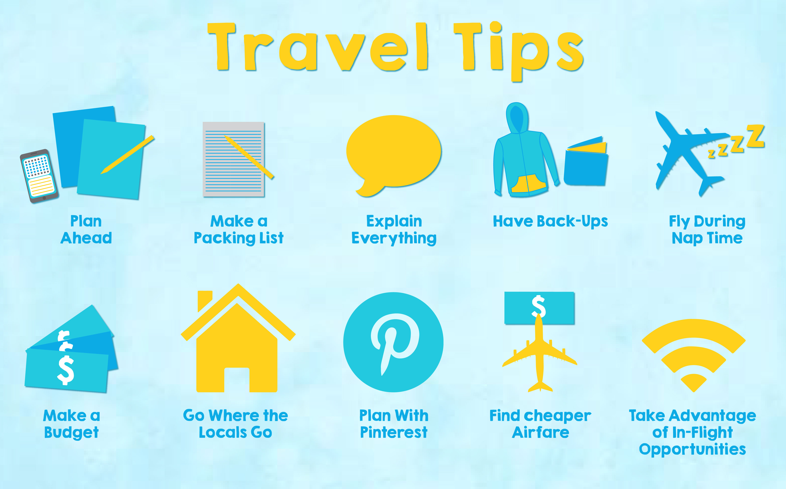](http://www.theguytravel.com/wp-content/uploads/2015/05/travel-tips.jpg)**

Image Source : theguytravel.com

**2. Preparation of Itineraries:**

A tourist journey involves preparation of different types of itineraries. There are different means of transport with their respective advantages and disadvantages. A travel agent advises the potential tourist to choose the most convenient course.

**3. Liaison with Providers of Service:**

A travel agent should maintain constant contact with the providers of various services like the transport companies, hotel managers and providers of surface transport like motor cars from airport to hotel and for sightseeing etc.

**4. Ticketing:**

Selling tickets to tourists for different modes of transport like air, rail and sea is a very important function of a travel agent. Ticketing is not an easy job as the range of international air fares is very complex. Computerized Reservation System (CRS) has revolutionized the reservation system both for air and train tickets and also a room in a hotel.

**5. Provision of Foreign Currencies:**

Provision of foreign currency to an intending foreign tourist is an important function of a travel agent. The Government of India allows an Indian traveler going abroad 10,000 US $.The travel agent will arrange for the purchase of foreign exchange on behalf of his intending travelers. This facility will save a lot of time and harassment for the intending tourists.

**6. Insurance:**

Insurance for personal accident risks and risk for loss of baggage is an important function of a travel agent. The idea of buying a package of travel, accommodation and perhaps some ancillary services such as entertainment became established in Western Europe in the 1960s. By 1970, tour operation had become a full-fledged part of tourism. Its growth was spectacular.

**3.3 Advantages or Disadvantages of tours and travelling agencies:**

**Advantages**

* You are free to choose there and when to go. You are free to change you hotel of your return ticket.
* You are most likely to see the places, not shown to usual tourists.
* It’s a kind of challenge. Can’t imagine your holyday without risk and adrenaline? So, this variant is for you
* You can seek and find a cheaper variant and not just accept what the agency offers.

**Disadvantages**

* Once again – risk. You are not quite safe when traveling alone in the foreign country. Nowadays you are not quite safe anywhere, but still
* It causes some problems in the stage of organization – getting a visa can be a trouble. Interview, invitation and a lot of documents – all this can be inevitable. So, prepare to waste some time and nerves.

**3.4 Requirements specifications:-**

**1. Selecting your Niche Market**

The competition in the online travel industry has spiked up due to the increasing number of travel agencies every year in the market. Each one is trying to offer something different to the people and creating new segments in the industry. The question is what you can offer that will make your new online travel agency stand out. The perfect way to attract customers is by presenting them with something unique that only you have. With enough research and market study, you may find what the industry lacking. If you can identify with these difficulties, it will help you in coming up with a reasonable solution to tackle it and turn that into your niche. This would give you an out of the box business model. Do you think you can help travelers make the best of their experience? Then focus on that particular niche, it will help you be the ideal travel agency that customers will particularly refer to. I believe that the best way to find your niche is learning from your own experiences, picking something that you are passionate about. Let’s take an example, if you have your mind set onto adventure travel and have a good experience around it; you could pursue it as your niche market! This will help you understand what is required and what you can do in that area to ease the traveler’s leisure trip. Some people look for thrill-seeking activities like trekking, mountain sky-diving, paragliding, etc. as an adventure; while others might prefer something slightly less risky like camping, cycling or horseback riding. Think of these emerging needs of people and provide them with your exceptional services.

**2. Research and Planning**

When starting a new business, you should [research and learn](https://quicktravelaffiliate.com/resources/how-to-become-a-travel-agent-in-this-day-age-of-internet/) about every little detail associated with it. Especially with the online travel industry that is very vast and filled with numerous options. This research will help you figure what exactly is required in the market right now, what is trending, preferences of the consumer, etc. and map your business plan accordingly. Planning every aspect of your travel agency in advance will be beneficial in the long run, especially when it comes to dealing with the competition. If you stick to your pre-planned business strategy and make a statement in the industry you won’t get distracted from your goals and the competitors will start focusing on them.

**3. Marketing**

Once you have decided your niche in the market and set yourself up, the next step in the ladder is marketing. As a business owner, you will need something to represent your brand to the people and make them aware of the services you offer. This has become relatively easier than before due to the extensive reach of the internet. If used smartly the internet is very powerful. You could use social media, blogs, search engines, and e-advertisement methods to reach out to people, let them know about your travel agency and why they should go for it. Another thing is to make your website attractive and user-friendly, it is the first thing consumers notice it should be good enough to give them a comfort zone. It is a great idea to encourage your clients to share their reviews about experiences they have had with your travel agency, which will help your future prospective clients understand the actual consumer relationship value you build.  People are more likely to come to you if they see how promising your services are. I can assure you that your hard work and efforts will definitely pay off when the customers start coming in.

**4. Registration**

To be able to run your online travel agency smoothly you need to have all the right documents in place. Luckily, travel agencies are the easiest to deal with when it comes to legal formalities, just remember to register your business and follow whatever requirements stated for travel agents by your local laws.

**5. Building Relationships**

I believe the most important thing for any business to be successful is establishing a healthy relationship with your clients. Staying in touch with your customers, letting them know they are important to your business, offering them special deals is a good way to secure their faith in your agency. Marketing your agency using different strategies will promote your brand name, but to be really successful in the business you will need the trust of your customers. Maintaining a strong relationship with your customer is the key to prospering in the online travel industry. As you can see there are various things to do when you are starting with an [online travel agency](https://quicktravelaffiliate.com/resources/start-online-travel-agency-year/). You will need different kinds of resources and support, so take a deep breath and get on with it. Make thorough research and find your niche which will attract customers. Do not hesitate to use whatever tools possible to promote your business and always interact with your clients.

**3.5 Functional or Non Functional Requirements:**

**Non-Functional Requirements:**

|  |
| --- |
| - The customers do challenge for fun traveling with check in(get point to find discount)  - Promotion can change by partner and admin.  - The customers can add new place if in the search and map doesn't have by fill in inside website helper function.  **Functional Requirements:** |

The customers must register for create the account and login using username and password to use function in the application

* + The customers can view or find the information of hotel, tourist attraction.
  + The customers can search for booking hotel, flight after select date time to go.
  + The customers can find the information and the calculate system of time, ways, price to the destination place.
  + The customers can review place or find another friends and people reviews.
  + The customers can see private history with analyze with booking, transport, price, time, etc. And keep or share the information.
  + The customers can use function dictionary to translate sentences for communication with different language of travelers.
  + The customers can note with text or plan trip with themselves
  + The customers can chat with their friends.
  + The customers can manage and see their profile.
  + The customers can find the location themselves and share location if they want.
  + The customers can see whether inside map or place that they want to go.
  + The customers can view friend's photo using newsfeed.
  + The customers can view friends in the map with real time, it will show status of customers too if turn on app and turn on share location mode it will show that person with green color.

**3.6 Use Case Diagrams:-**

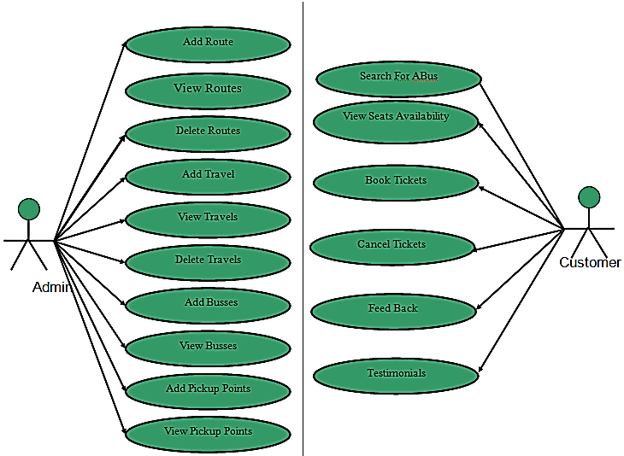

**Figure 3.6**

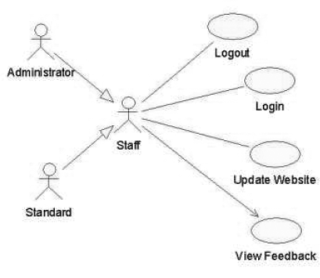

**Figure 3.6.1**

**Chapter 4**

**System Design**

**4.1 Architecture:**

A system architecture diagram would be used to show the relationship between different components. For a web application the system architecture design would include components such as, database, application server, web server, internet, browser etc.

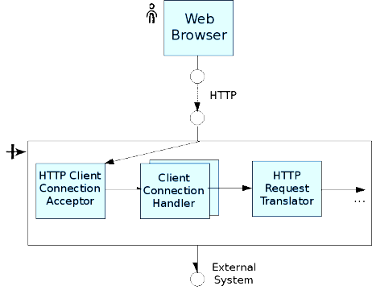

**Figure 4.1**

**4.1.2 Data flow diagram 0-level DFD:**

The initial-level DFD is then exploded to produce a Level 1 DFD which models the details of the system. The DFD shows how the system will be work. The level 1 DFD shows the how the systems will work. Also known as DFD, Data flow diagrams are used to graphically represent the flow of data in a business information system. DFD describes the processes that are involved in a system to transfer data from the input to the file storage and reports generation. As DFD, Data flow diagrams are used to graphically represent the flow of data in a business information system. DFD describes the processes that are involved in a system to transfer data from the input to the file storage and reports generation helded inside data ouput.

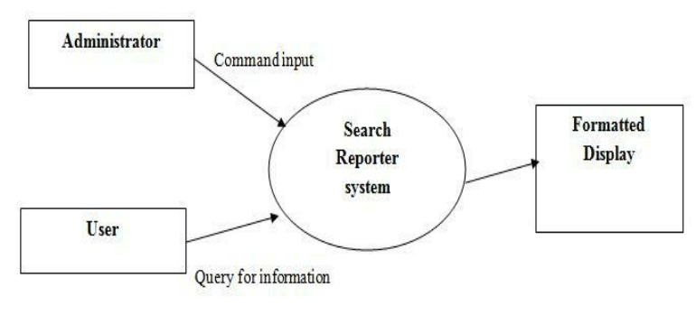

**Figure 4.1.2**

**4.1.3 1-level DFD:**

The context-level DFD is then exploded to produce a Level 1 DFD which models the details of the system. The Level 1 DFD shows how the system is divided into sub-systems (processes), and how each processes deals with one or more of the data flows to or from an external entity, and how the processes together provide all of the functionality of the system. The level 1 DFD also identifies the internal data stores which must be there for the system to do its job, and shows the data flow between the various parts of the system.

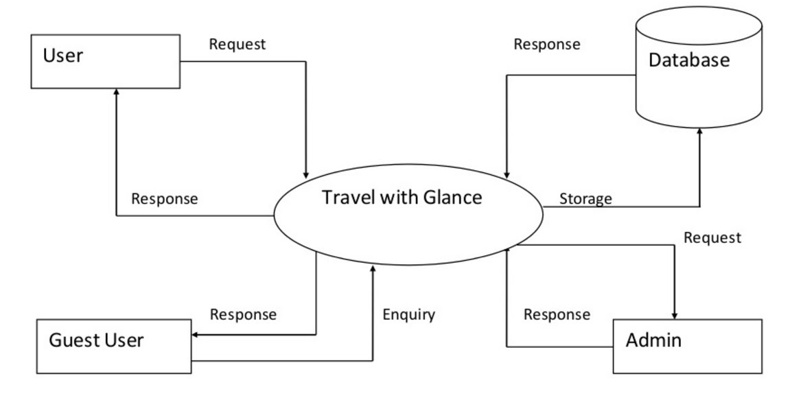

**Figure 4.1.3**

**4.1.4 2-Level DFD**

The Level 2 DFD is the further decomposition of Level 1 processes into sub-processes (subsystems) which give detailed description of the data flow in each process. Here we have decomposed the process View enrolled student in the sub-process Take attendance. The faculty selects the course ID and get the details of the enrolled student and then he can take attendance for that particular course. The data storage used in this level is the Attendance list.

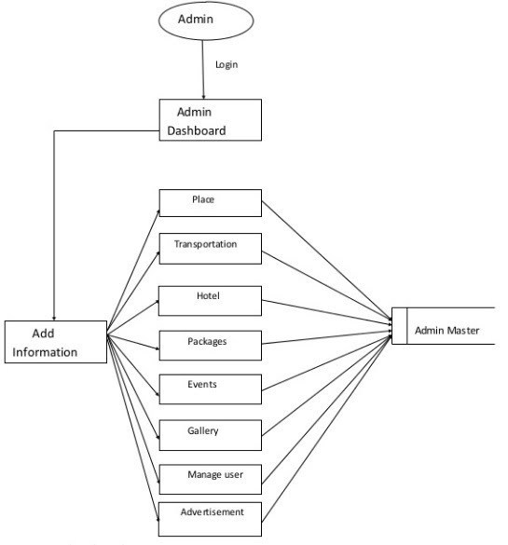

**Figure 4.1.4**

**4.2 Design Constraints:**

In engineering design, particularly in the use of computer-aided drafting and design, in the creation of 3D assemblies and multi body systems, the plural term "constraints" refers to demarcations of geometrical characteristics between two or more entities or solid modelling bodies. These delimiters are intentional in defining diverse properties of theoretical physical position and motion, or displacement. In addition, 2D sketches including the ones used to create extrusions and solid bodies can also be constrained. Design constraints are limitations on a design. These include imposed limitations that you don't control and limitations that are self-imposed as a way to improve a design. The following are common types of design constraint. Each constraint represents a connection or alignment to another view, the parent layout, or an invisible guideline. Each constraint defines the view's position along either the vertical or horizontal axis; so, each view must have a minimum of one constraint for each axis, but often more are necessary.

There are currently various types of constraints that you can use:

* Relative Positioning
* Margins
* Central Positioning
* Circular Positioning
* Visibility
* Dimension Constraints
* Chains
* Virtual Helper Objects
* Optimizer

**4.2.1 Commercial Constraints**

Basic commercial constraints such as time and budget.

**4.2.2 Requirements:**

Functional requirements such as specifications of features for a website. Data flow from are used to graphically represent the flow of data in a business information system. DFD describes the processes that are involved in a system to transfer data from the input to the file storage and reports generation.

**4.2.3 Non-Functional Requirements**

Requirements that specify intangible elements of a design. For example, a non-functional requirement that a building be accessible.

**4.2.4 Compliance**

Compliance to applicable laws, regulations and standards.

**4.2.5 Style**

A style guide or multiple style guides related to an organization, brand, product, service, environment or project. For example, a product development team may follow a style guide for a brand family that constrains the colors and layout of package designs.

**4.2.6 Sensory Design**

Beyond visual design, constraints may apply to taste, touch, sound and smell. For example, a brand identity that calls for products to smell fruity.

**4.2.7 Usability**

Usability principles, frameworks and standards. For example, the principle of least astonishment.

**4.2.8 Principles**

The design principles of an organization, team or individual. For example, a designer who uses form follows function to constrain designs.

**4.2.9 Integration**

A design that needs to work with other things such as products, services, systems, processes, controls, partners and information.

**4.3 Design Methodology**

We used AGILE model in our Website development. A goal of agile software development is to focus more on producing working software and less on documentation. This is in contrast to waterfall models where the process is often highly controlled and minor changes to the system require significant revision of supporting documentation.

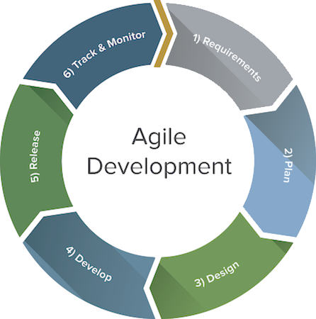

**Figure 4.3**

We choose AGILE model because we need to create a system that can be modularized in 2-3 months (90-100 days) of time. Our process was also based on these functionalities of AGILE Model:

* Optimize a process with right combination of technology
* Time-boxing and minimizing non-essential work leads to higher efficiency levels.
* Promotes adaptive planning

**4.4 High Level Design HLD:**

High Level Design (HLD) is the overall system design- covering the system architecture and database design. It describe the relation between various modules and function of the system. Data flow, flow charts and data structures are covered under HLD.

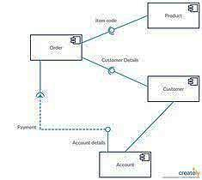

**Figure 4.4**

**4.4.1 Conceptual or Logical:**

This view shows the logical functional elements of the system. Each component represents a similar grouping of functionality. For UML, this would be a component diagram or a package diagram.

**4.4.1 Login Activity Diagram**

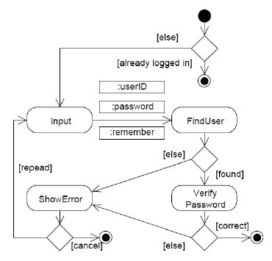

**Figure 4.4.1**

**4.4.1.2 Logout Activity Diagram**

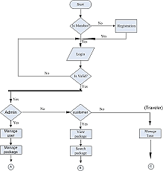

**Figure 4.4.1.2**

**4.4.2 Process**

Sequence Diagram Sequence diagram is an interaction diagram which shows how the processes interact with one another and in what order. It shows the object interactions arranged in time sequence. It represents the objects and classes involved in the scenario. It also shows the sequence of messages exchanged between that object which is needed to perform different functionality of the scenario. Sequence diagrams are associated with use case realizations of the Logical View of the system.

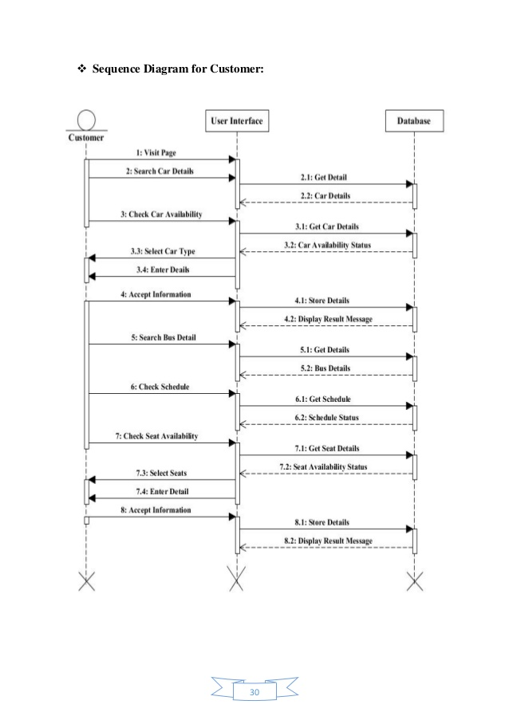

**Figure 4.4.2**

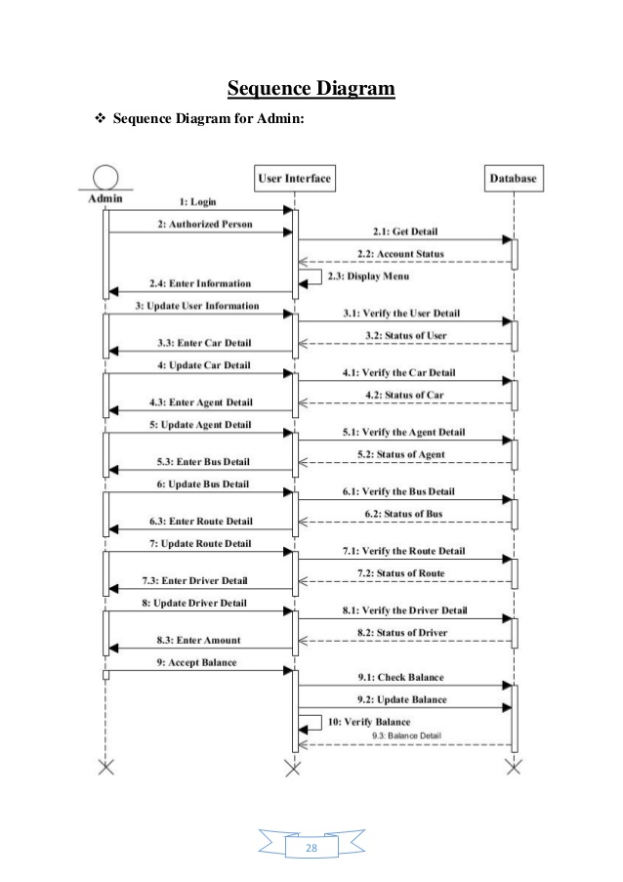

**Figure 4.4.2.1**

**4.4.3 Physical**

**Deployment diagram**:

A Deployment Diagram shows the configuration of run-time processing nodes and the components that live on them. Deployment diagrams address the static deployment view of architecture. They are related to component diagrams in that a node typically encloses one or more components.

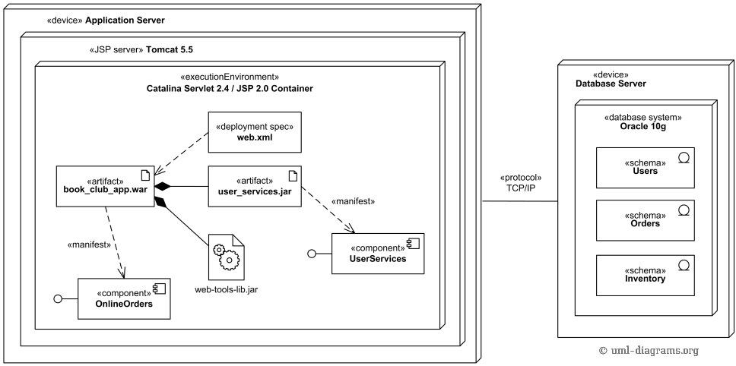

**Figure 4.4.3**

**4.4.4 MODULES:**

The entire project mainly consists of 2 modules, which are

* Admin module
* User module

**Admin Modules**.

1. Admin can create packages.
2. Manage packages.
3. Manage booking.
4. Delete packages.
5. Edit packages.

**User Modules.**

1. User Login/sign up.
2. Booking Tours.
3. Manage Booking.
4. Change Password.
5. Forgot password.

**4.4.5 Security:**

If you're selling anything online, you need to put some effort into securing your site with an SSL certificate. The SSL will encrypt communications between you and your clients (i.e. a credit card number, Social Security number), which will allay their fears of providing such information, since there's so much identity theft on the web. VeriSign, Trust E, Entrust and Geo Trust are good options to explore.

**4.5 Low Level Design Class Diagram**

Class diagram is a type of static structure diagram which describes the structure of a system by representing the classes of the system, their attributes, operations and the relationships among these classes

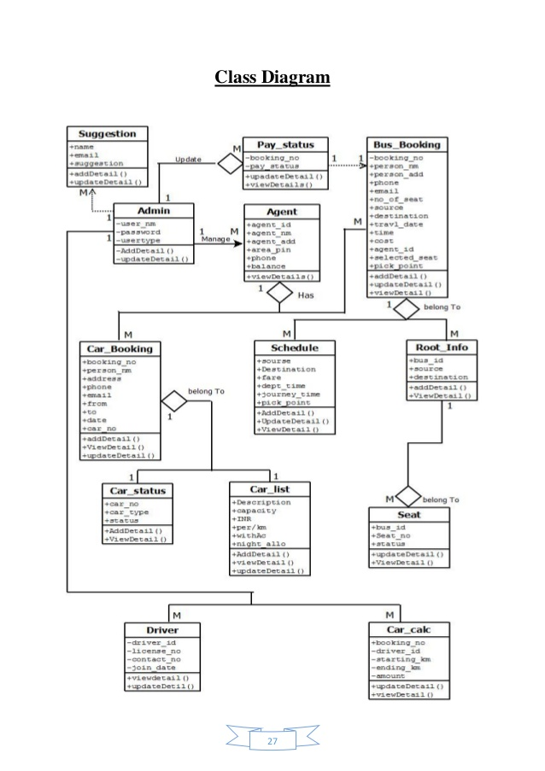

**Figure 4.5**

**4.6 Database Design**

ER Diagram The entity-relationship diagram is a data modelling technique that graphically represents information systems entities and the relationships between those entities. An ER diagram is a conceptual and representational model of data which is The ER diagram contains following elements:

Entities

Relationships

Attributes

**4.6.1 ER Diagram:**

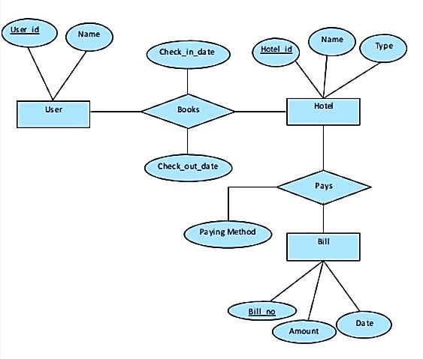

**Figure 4.6.1**

**4.6.2 ER Diagram of Admin:**

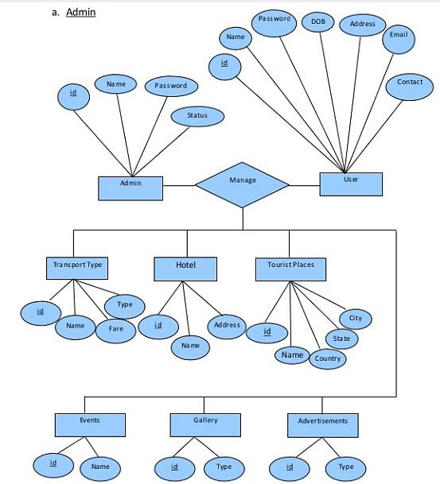

**Figure 4.6.2**

**4.6.3 ER Diagram of User:**

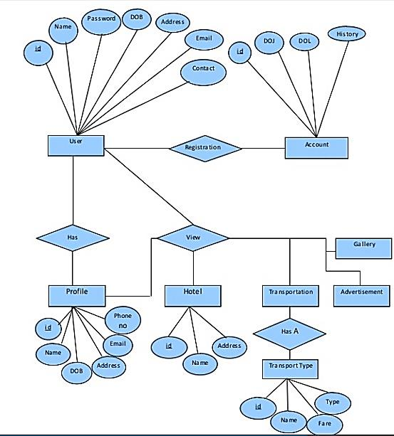

**Figure 4.6.3**

**4.7GUI Design:**

**4.7.1 Homepage**.

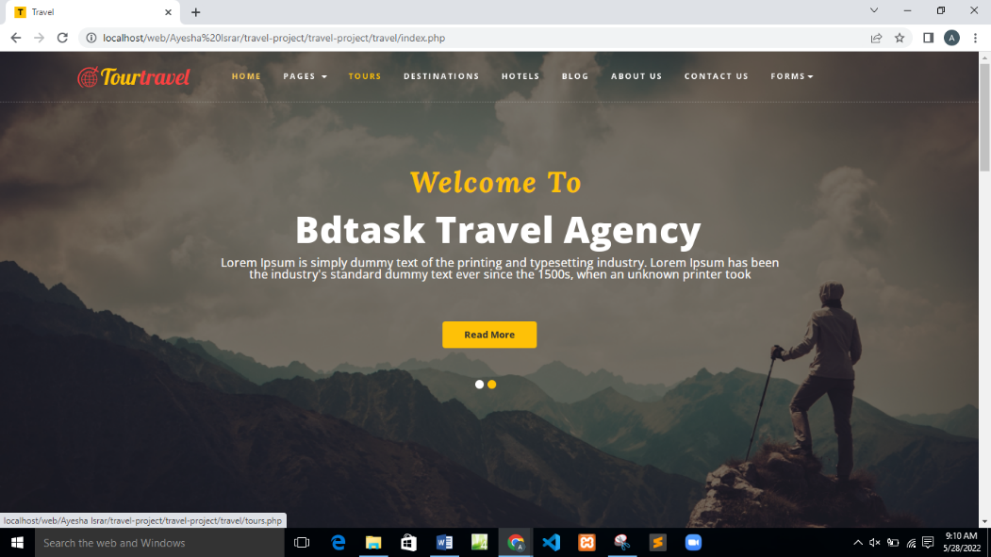

**Figure 4.7.1**

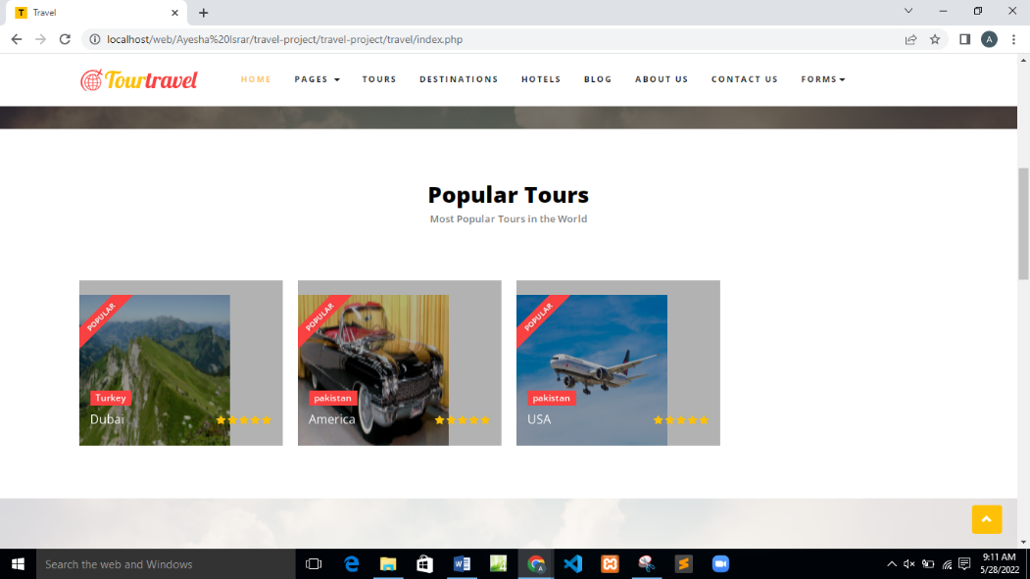

**Figure 4.7.1.1**

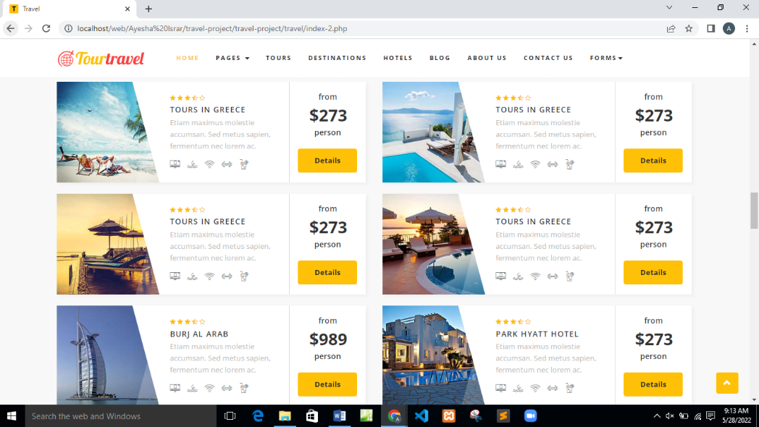

**Figure 4.7.1.2**

**Description of Image:-**

This is the homepage of our website. Some features of websites are show in these images all kind of packages and details.

**4.7.2 User Sign in**

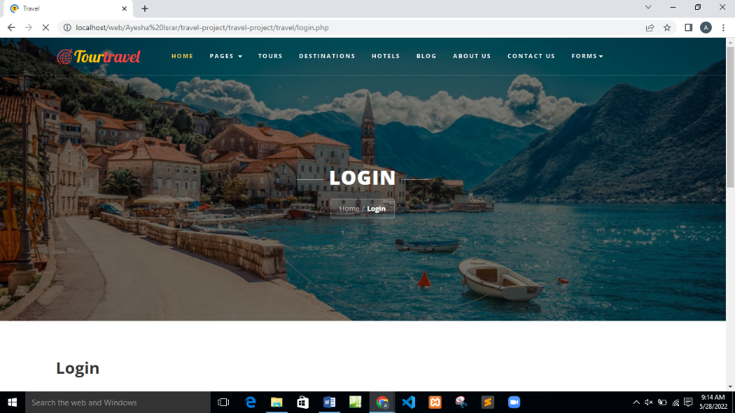

**Figure 4.7.2**

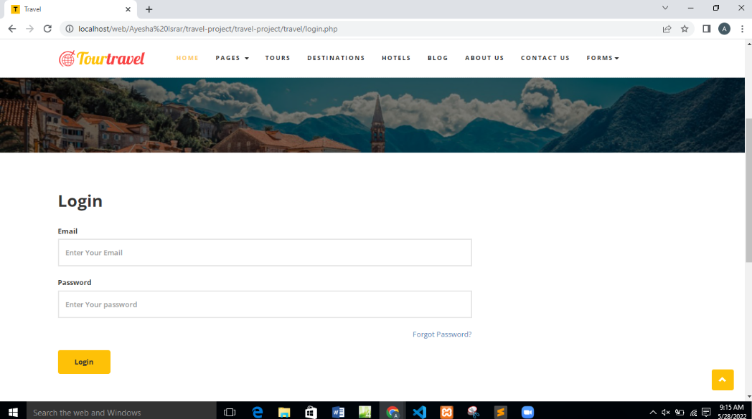

**Figure 4.7.2.1**

**Descriptions of Login Page:-**

This page is design for user. So with the help of login page user can enter the website and is enable for booking.

**4.7.3 User Registration**

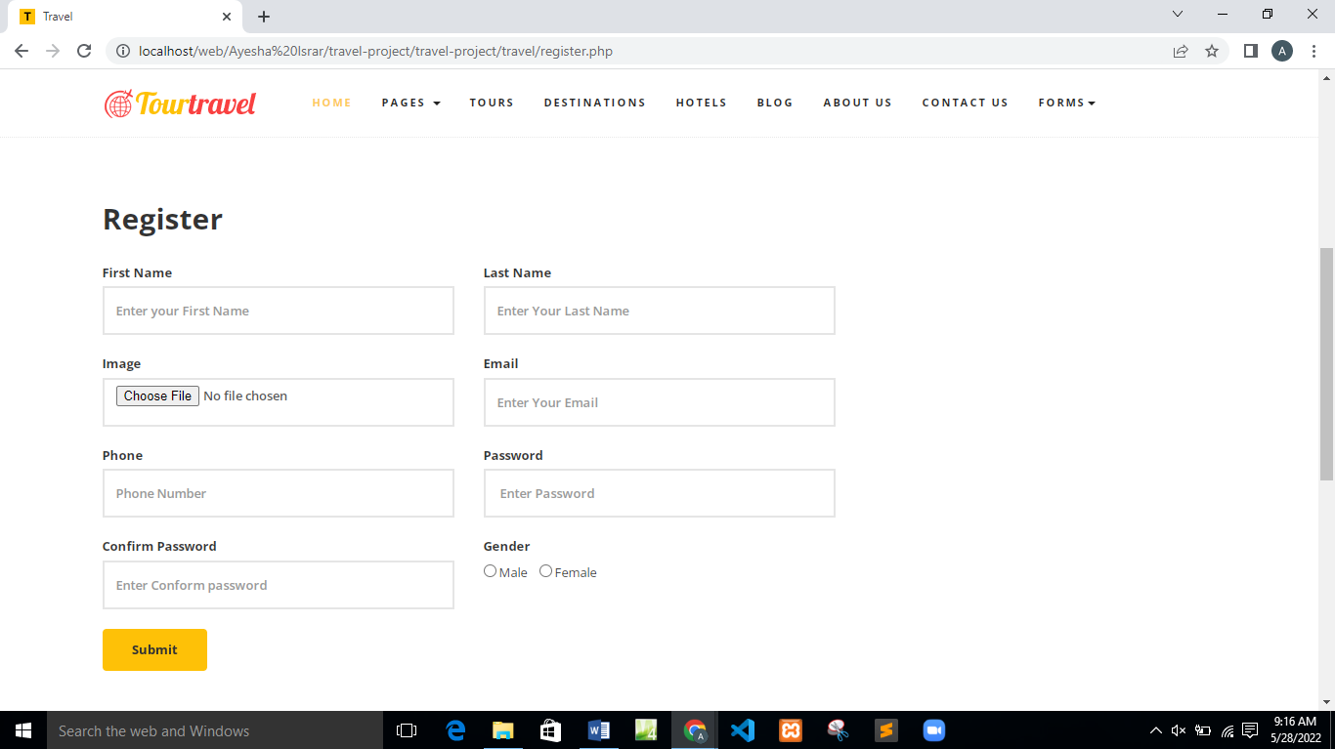

**Figure 4.7.3**

**Description of Registration page:-**

With the help of this page the user can easily register his/her self. Once the user can register then he will be login to the website.

**4.7.4 Tours Details**

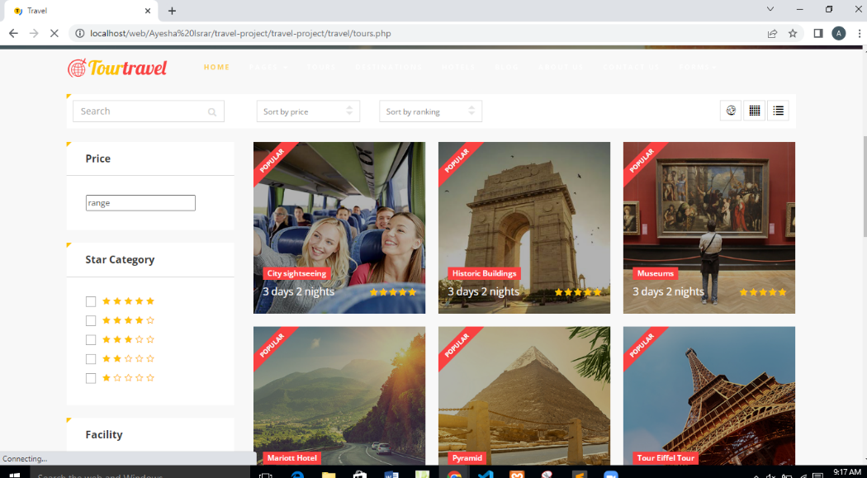

**Figure 4.7.4**

**Description of Tours Details:-**

In this page user can see all packages and their detail.

**4.7.5 Booking Now**

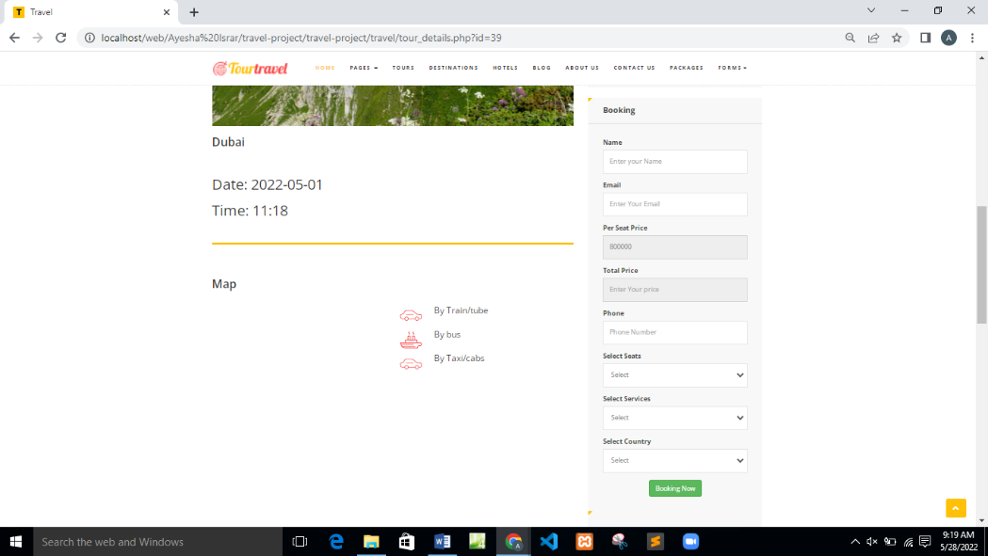

**Figure 4.7.5**

**Description of Booking:-**

With the help of this page user can easily book their tour. Our Tour Booking System is a complete management solution for individual passenger reservations on extended tours, day excursions and express services. Tour Booking System is a complete management solution for individual passenger reservations on extended tours, day excursions and express services. Tourism means people traveling for fun. It includes activities such as sightseeing and camping. People who travel for fun are called "tourists". Places where many tourists stay are called "resorts". ... Some people travel to do an activity which they cannot do at home.

**4.7.6 Admin Panel:-**

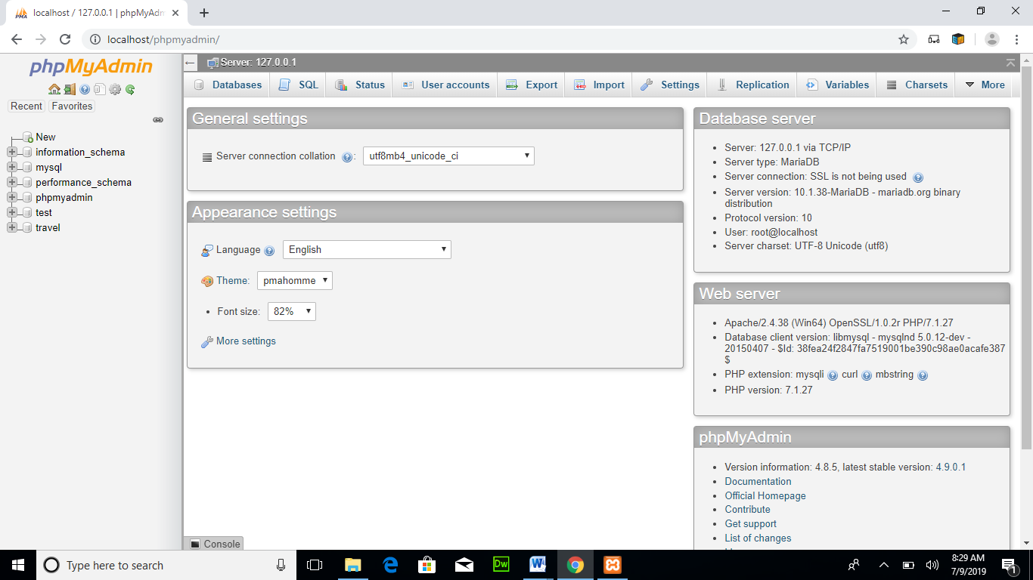

**Figure 4.7.6.1**

**Description of Admin panel:-**

In this image the admin panel is show. To show the admin panel we can use the command **localhost/phpmyadmin/**.

**4.7.6.2 View booking from Admin side**

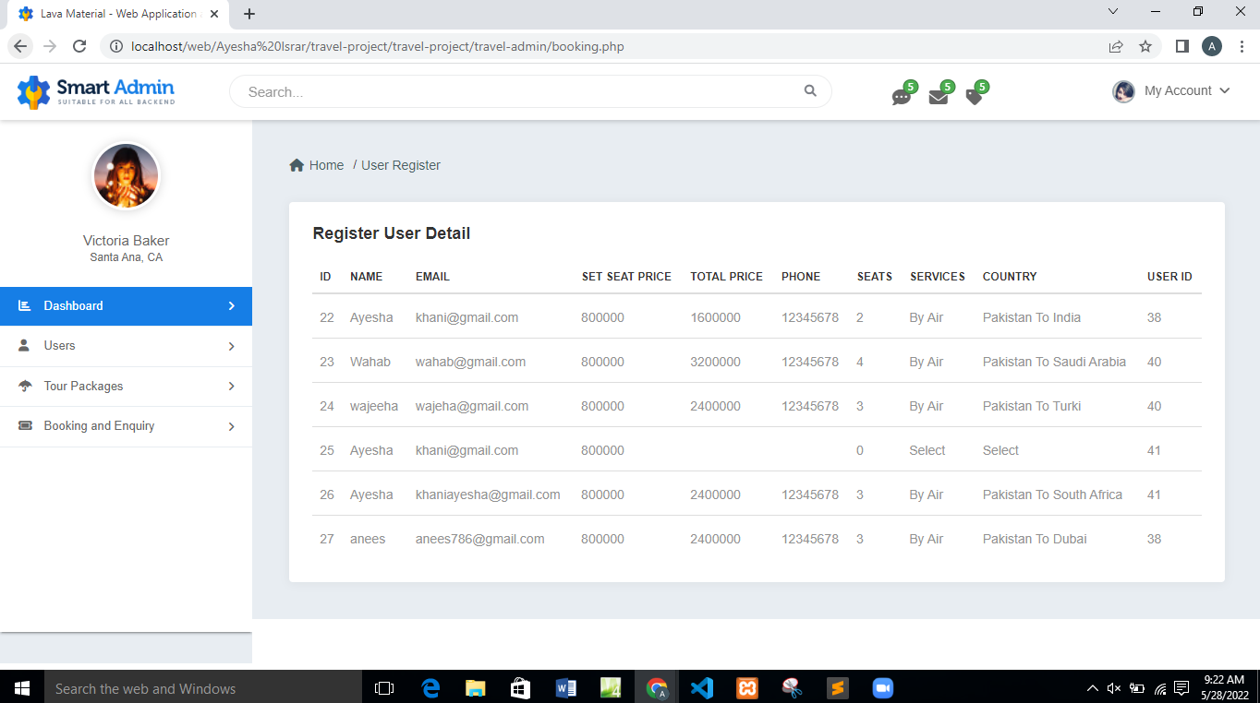

**Figure 4.7.6.2**

**Description of view booking:-**

View booking from admin side will help out the admin to view the user who book the tours.

**4.7.6.3 Add new packages**

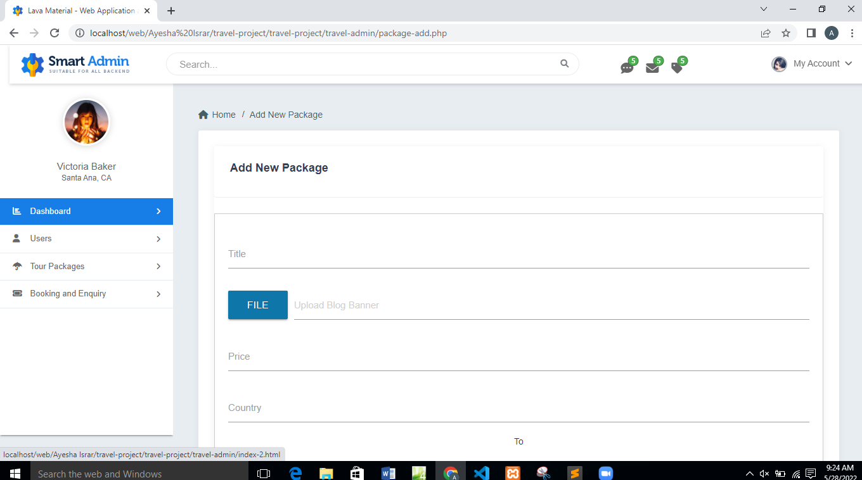

**Figure 4.7.6.3**

**Description of add new Packages:-**

From this admin will add new packages for user. A package together by a vendor known as a [tour operator](https://en.wikipedia.org/wiki/Tour_operator). Other services may be provided such a [rental car](https://en.wikipedia.org/wiki/Rental_car), activities or outings during the holiday. Transport can be via [charter airline](https://en.wikipedia.org/wiki/Charter_airline) to a foreign country, and may also include travel between areas as part of the holiday. Package holidays are a form of [product bundling](https://en.wikipedia.org/wiki/Product_bundling). Dynamic packaging is a method that is becoming increasingly used in package holiday booking procedures that enables consumers to build their own package of flights, accommodation, and rental car instead of a pre-defined package.

**2**

**4.7.6.4 View User Registration**

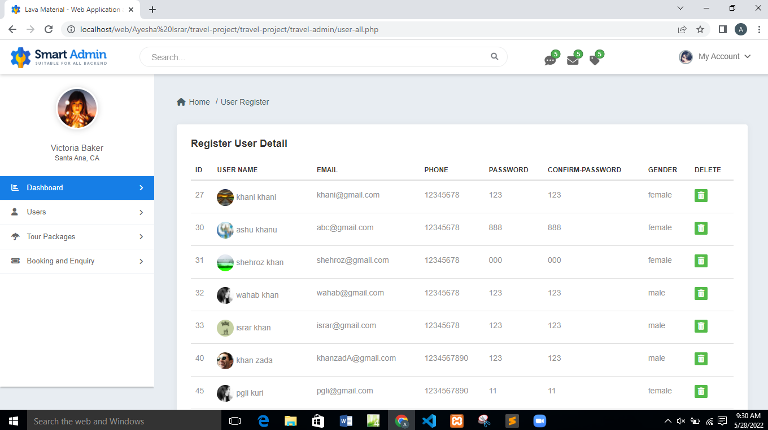

**Figure 4.7.6.4**

**Description of Register User:-**

Admin will see that user who will register themselves. And Admin can also see the all details of user like Phone number, password and also have ability to delete the register if he/she think the user is unauthorized.

**4.8 External Interface**

External interfaces are typically a product's lifeline to the outside world. Such interfaces may be used for a number of purposes, including connecting to peripherals, field programming, or testing during product manufacturing. Typical interfaces include FireWire, Network. The system use some external interfaces such as hardware interface and software interface and communication interface.

**Hardware Interface**

An architecture used to interconnect two devices together. It includes the design of the plug and socket, the type, number and purpose of the wires and the electrical signals that are passed across them. In the system use some hardware such as Fire wire, Smart phone, and laptop.

**Software Interface**

Programming interfaces are the languages, codes and messages that programs use to communicate with each other and to the hardware. In the system use some programs such as java libraries, Android Studio and API (version).

**Communication Interface**

An electronic circuit, usually designed to a specific standard that enables one machine to telecommunicate with another machine. State the requirements for any communication functions the product will use, including e-mail, Web browser, network communications protocols, and electronic forms.so in the IRH use internet, GCM and environment, the coordination and interaction between several work groups is used to communicate plans and control production activity. This interaction can be schedules, human interactions, computer systems, or any other medium of communication. Product combination of different of components (chips/devices) arranged on a printed circuit board it interconnects the various components with in an embedded product is refereed as devices (board level). An electronic circuit, usually designed toa specific standard that enables one machine to communicate with another machine.

**Chapter 5**

**System Implementation**

System implementation is a stage in system life cycle whereby a new system is developed, installed and made ready for use. It is this stage that all details and key point in the requirement specification are practical. System implementation therefore, is a very essential stage in which its success determines to a great extent the success of the new system. At this instance, after all is said and done the system is duly ready to be implemented (Online tours and travelling system).System design is concerned mainly with the coordination of activities, job procedures and equipment utilization in order to achieve organizational objectives. It addresses data input and output data, processing and interface.

**5.1 System Architecture**

An architecture is "the fundamental organization of a system, embodied in its components, their relationships to each other and the environment, and the principles governing its design and evolution.

**5.1.1 System Internal Components**

**5.1.1.1 Front End Elements**

People often describe the website as having front end and back end as well. In this analogy, the front-end is what you see and is also referred to as the client-side and is sometimes considered “interface”. The back-end of the website industry is often called the server-side. For developing website using HTML, CSS and Bootstrap language is front end. The backend of website using MySQLi database which is real time database for storing the data and later retrieve the data in website. There is may be many layers between the hardware and end user.

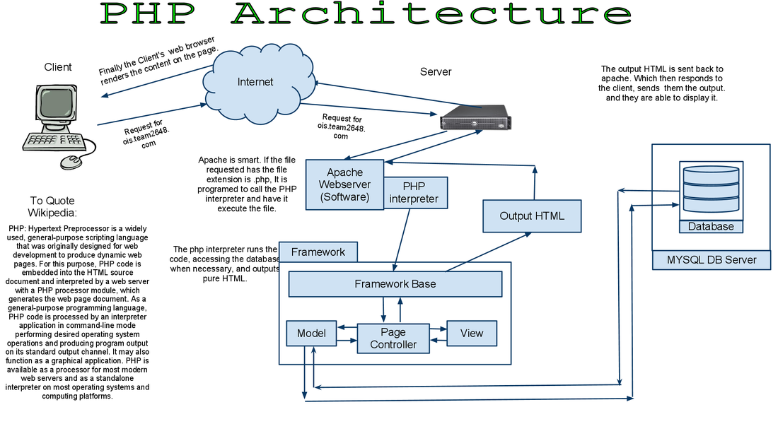

**Figure 5.1.1.1**

**5.1.1.2 The navigation structure**

This is not the same as the sitemap, through that might represent it. The navigation structure is the order of the page, the collection of what link to what. Usually it is held together by at least one navigation menu.

**5.1.1.3 Graphic Design**

Many of the elements described, such as the logo, the navigation menus, the layout, images, etc., fall under the general category of graphic design. But graphic design is more than the sum of these parts. It is the overall look and feel the website will have as a result of proper use and integration of all these elements. A website with bad graphic design is usually obvious to everyone except the person who put it together. But doing graphic design well takes a special combination of talent, skill, and education.

**5.1.1.4 Back End elements**

Some websites are entirely static. They are the same every time you visit. You never give them information, there are no polls, bulletin boards, or referral forms. If you want to find something on the website, there is no search box, you just look around until you find it. But such sites are growing rarer as the internet becomes an ever greater part of people’s lives. Modern sites are searchable. They offer new images on each visit. They allow the user to request more information, or to post their own thoughts. Many can be updated directly from a simple panel or word-processing program. A lot of websites are data driven, meaning that web pages are actually created on the fly, in response to the specific needs of the user. All of these functional elements are called back-end elements. In some cases there are many different ways to do the same thing. So the line between elements is often blurry.

**5.1.1.5 Online databases**

Databases allow us to store, sort, search through, and display large amounts of information. Online databases bring this technology seamlessly to the Web.

**5.1.1.6 Multi-media**

Some websites call for more than just text and images. Photo-tours, video-clips, sound-clips all can add to the experience if they are well matched to the type of site and profile of the target audience.

**5.1.1.7 Security**

All kinds of information can be found hidden on websites. Trade secrets, proprietary programming, client credit card numbers, and every imaginable piece of personal data. Press releases have been uncovered early, strictly internal memos have been leaked, all because the internet has many ways of exposing data. If you are passing information online that is not meant for everyone, then you want to ensure you have the right level of security.

**5.1.2 Tools and Languages**

The system runs on a number of languages and tools which make it fully responsive and dynamic. These include:

1. **PHP:**

It serves as the server-side scripting tool on this application. PHP allows the web application to be responsive and dynamic. What this means is that the server hosting the content can respond to user requests in different manners. PHP is now officially known as “PHP: Hypertext Preprocessor” It is a server-side scripting language usually written in an HTML context. Unlike an ordinary HTML page, a PHP script is not sent directly to a client by the server; instead, it is parsed by the PHP binary or module, which is server-side installed. HTML elements in the script are left alone, but PHP code is interpreted and executed. PHP code in a script can query databases, create images, read and write files, talk to remote servers – the possibilities is endless. The output from PHP code is combined with the HTML in the script and the result sent to the user’s web-browser, therefore it can never tell the user whether the web-server uses PHP or not, because the entire browser sees is HTML.PHP’s support for Apache and MySQLi further increases its popularity. Apache is now the most-used web-server in the world, and PHP can be compiled as an Apache module. MySQLi is a powerful free SQL database, and PHP provides a comprehensive set of functions for working with it. The combination of Apache, MySQLi and PHP is all but unbeatable. That doesn’t mean that PHP cannot work in other environments or with other tools. In fact, PHP supports an extensive list of databases and web-servers. While in the mid-1990s it was ok to build sites, even relatively large sites, with hundreds of individual hard-coded HTML pages, today’s webmasters are making the most of the power of databases to manage their content more effectively and to personalize their sites according to individual user preferences.

**Reason for using PHP**

There are some indisputable great reasons to work with PHP. As an open source product, PHP is well supported by a talented production team and a committed user community. Furthermore, PHP can be run on all the major operating systems with most servers.

1. **Learning PHP is easy:**

Basic is easy any interpreted language should be easy to learn. Since you are isolated from the system (no pointers to use, no memory to allocate). The other advantage that all modern interpreted languages share is good associative array constructs. **b)** **Its Performance:**

While we can build an application that serves millions of pages a day on a server, when we really look at the performance of the language it sucks. We are still orders of magnitude from real performance. Not only that, but since PHP is designed around a single process model our ability to share data structures or connection pool resources is left to native code. There are many languages which are available at very less cost. There are some languages which are available at very less cost like below: PHP, C, C++**) It’s Open Source, We can modify it.** We can modify it if you need a hole in your head! Technically the point is that it’s an open source project and they release patches often. You’re point is that the community is actively working out the bugs. So, what any active language is doing this...Unfortunately C, C++ and Perl have all “died” at this point and will pretty much remain static at their current functionality

**2. HTML:** This stands for Hypertext Markup Language. It is a web standard for achieving text, color etc. for the web application.

**3. CSS:** This creates a fluid design for the web application. It works hand in hand with HTML to create a user-friendly design on the web application.

**4. MySQLi:** It is a relational database system that is designed to work with multiple systems. This tool is used to manage information in the database of both small and large systems. The system has PHP as its base which works hand in hand with the other languages and tools to bring a dynamic experience to the Medical Inventory System. Due to the fact that the system runs online, the use of PHP and JavaScript were vital so as to improve interactivity with the users of the system. Also, HTML and CSS help to fully encapsulate the dynamisms and interactivity of a standard web-based system. On the system, all the products are stored in various tables in the database, for clear distinctive purposes. What the user sees is the Graphical User Interface (GUI) which allows easy access to products and services. The GUI of the system is as a result of all the tools and languages, both at the server-side and client-side, coming together to form a cohesive unit. All the user has to do is to provide correct login details, which is verified by the database, to access all products. There is also an administrative dashboard which allows only the administrator to add or remove users. This feature was introduced to check for any intruders or unauthorized personnel in the system, who may want to order medicines illegally.

**5.1.3 System Security Measure**

The objective of system security is the protection of information from theft, corruption and other types of damage, while allowing the information to remain accessible and productive. System security includes the development and implementation of security countermeasures. There are a number of different approaches to system security, including the use of a data encryption, passwords. The mass of security functionality employed by today's networked world, might deceive us into believing that our jobs as secure system designers are already done. However, computers and networks are incredibly insecure. The lack of security stems from two fundamental problems. Systems, which are theoretically secure, may not be secure in practice. Furthermore, systems are increasingly complex; complexity provides more opportunities for attacks. It is much easier to prove that a system is insecure than to demonstrate that one is secure to prove insecurity, one simply exploits certain system vulnerability. On the other hand, proving a system secure requires demonstrating that all possible exploits can be defended against (a very daunting, if not impossible, task).

**5.1.3.1 Firewalls**

Firewalls work like a filter between your computer/network and the Internet. You can program what you want to get out and what you want to get in. web firewall is a barrier to keep destructive forces away from your website. Firewall works behind the scenes to control the flow of data and will alert you if suspicious activities occur. On the outbound side, firewalls can be configured to prevent employees from sending certain types of emails or transmitting sensitive data outside of the network. On the inbound side, firewalls can be programmed to prevent access to certain websites (like social networking sites). A firewall is a network security system designed to prevent unauthorized [access](https://www.webopedia.com/TERM/A/access.html) to or from a private [network](https://www.webopedia.com/TERM/N/network.html). Firewalls can be implemented as both [hardware](https://www.webopedia.com/TERM/H/hardware.html) and [software](https://www.webopedia.com/TERM/S/software.html), or a combination of both. Additionally, firewalls can prevent outside computers from accessing computers inside the network.

**5.1.3.2 Encryption**

Data security is the most important aspect of Web security. Most of the data stored in databases is plain and open. While most of the data can be stored plain, sensitive data must be encrypted in the database. The cost of storing encrypted data isn’t much. As a matter of fact, these days, most of the new versions of database systems come with built-in encryption options. For example, SQL Server 2017 lets you encrypt the entire database using simple SQL commands. Some of the common data that must be encrypted include user ids, emails, passwords, social security numbers, date of birth records, credit card details, password hint answers, personal health records, private chats and messages, financial records, and banking information. On top of this, you could apply a double encryption on the most sensitive data such as passwords, credit card information, social security, and anything else you think is valuable. Hashing is recommended for password and other sensitive data encryption.

**5.1.3.3 Authentication**

Broken Authentication is the number-two cause of Web application security risks. By implementing recommended best practices, developers can avoid major security risks in their applications. Applications that implement incorrect authentication and session variables lead hackers to hijack passwords, keys, session tokens, and other credentials stored in sessions. Authentication is used by a server when the server needs to know exactly who is accessing their information or site.Authentication is used by a client when the client needs to know that the server is system it claims to be.In authentication, the user or computer has to prove its identity to the server or client. Following are authentication steps to secure a system. A non-authenticated user-agent asks for a content that cannot be accessed without some kind of permissions. The web application returns an authentication request, usually in form of an HTML page containing an empty web form to complete.

**5.1.3.4 Password**

The most widely used method to prevent unauthorized access is to use passwords. A password is a string of characters used to authenticate a user to access a system. The password needs to be kept secret and is only intended for the specific user. Simple passwords is one of the reasons most hackers get into a system. The complexity of passwords, also known as password strength, is a measure of the effectiveness against attackers. Here are some of the key points developers can enforce to create complex password.

**5.1.4 Database Security Measure**

Database security refers to the collective measures used to protect and secure a database or database management software from illegitimate use and malicious threats and attacks. It is a broad term that includes a multitude of processes, tools and methodologies that ensure security within a database environment.

**5.1.4.1 Authentication**

The client has to establish the identity of the server and the server has to establish the identity of the client. This is done often by means of shared secrets (either a password/user-id combination, or shared biographic and/or biometric data). It can also be achieved by a system of higher authority which has previously established authentication. In client-server systems where data (not necessarily the database) is distributed, the authentication may be acceptable from a peer system. In XAMPP database system, the authentication process is initiated by the CONNECT statement. After successful execution of CONNECT, the resources of the database become potentially available.

**5.1.4.2 Authorization**

The authorization allows to configure the user accounts that can access site or application. Use authorization in combination with authentication to secure access to content on your server. Authentication confirms the identity of a user, while authorization determines what resources users can or cannot access. . Authorization is permission given by the DBMS to use defined database resources and is based on the authentication identifier and a record of the permissions the owner of that identifier has. The identifier is recorded with the objects the user is allowed to access and the actions that can be performed on those objects. These are recorded either as a separate security database or as part of the normal system tables – accessible only to those with DBA privileges and higher. The owner has privileges on the objects owned. No other user can have any privileges (or even know the object exists) unless the owner supplies the necessary permission. In normal development, the DBA or system administrator will be the owner of the major assets.

* + - 1. **Anonymous User Server Access**

There always exists an anonymous [user](http://sql602.sourceforge.net/helpdir-en/xml/html/usermanagement.html) on each server that logs on using empty username and password. If a server is accessible from the network it's desired to restrict anonymous user access. It can be done on various levels:

1. Anonymous user should be rejected from the [administrator groups](http://sql602.sourceforge.net/helpdir-en/xml/html/usergroups.html).
2. Anonymous user can be rejected from the application [roles](http://sql602.sourceforge.net/helpdir-en/xml/html/role.html) and his object and data [privileges](http://sql602.sourceforge.net/helpdir-en/xml/html/userinfo.html) can be removed.
3. By removing his privileges to the system tables the anonymous user is prohibited from creating new applications and other objects on the server.
4. Anonymous user can be denied from logging to a server completely. Therefore the anonymous user can't read the users list, trace the server logs, see application names and make illegal server requests.

The anonymous access ban is handled by the Disable Anonymous server [property](http://sql602.sourceforge.net/helpdir-en/xml/html/properties.html). It can be set from the Control Panel, System folder, on the Security tab of the Runtime parameters dialog. This property is set by a [security administrator](http://sql602.sourceforge.net/helpdir-en/xml/html/admins.html). If the anonymous access is banned, then (as a side effect) the list of users is not displayed in the combo box on the login window - users are required to type the name manually.

**5.1.4.4 Auditing/Logging**

Auditing is another good way to discover unwanted changes on your system. This includes monitoring logins (and attempted logins) to the operating system and database and reviewing logs regularly to detect anomalous activity. It is keeping a record of all the characteristics of your system when it is in a good, “healthy,” state and comparing it to the current state. By comparing the two versions of the same system side to side, you can detect all the inconsistencies and track their origin.